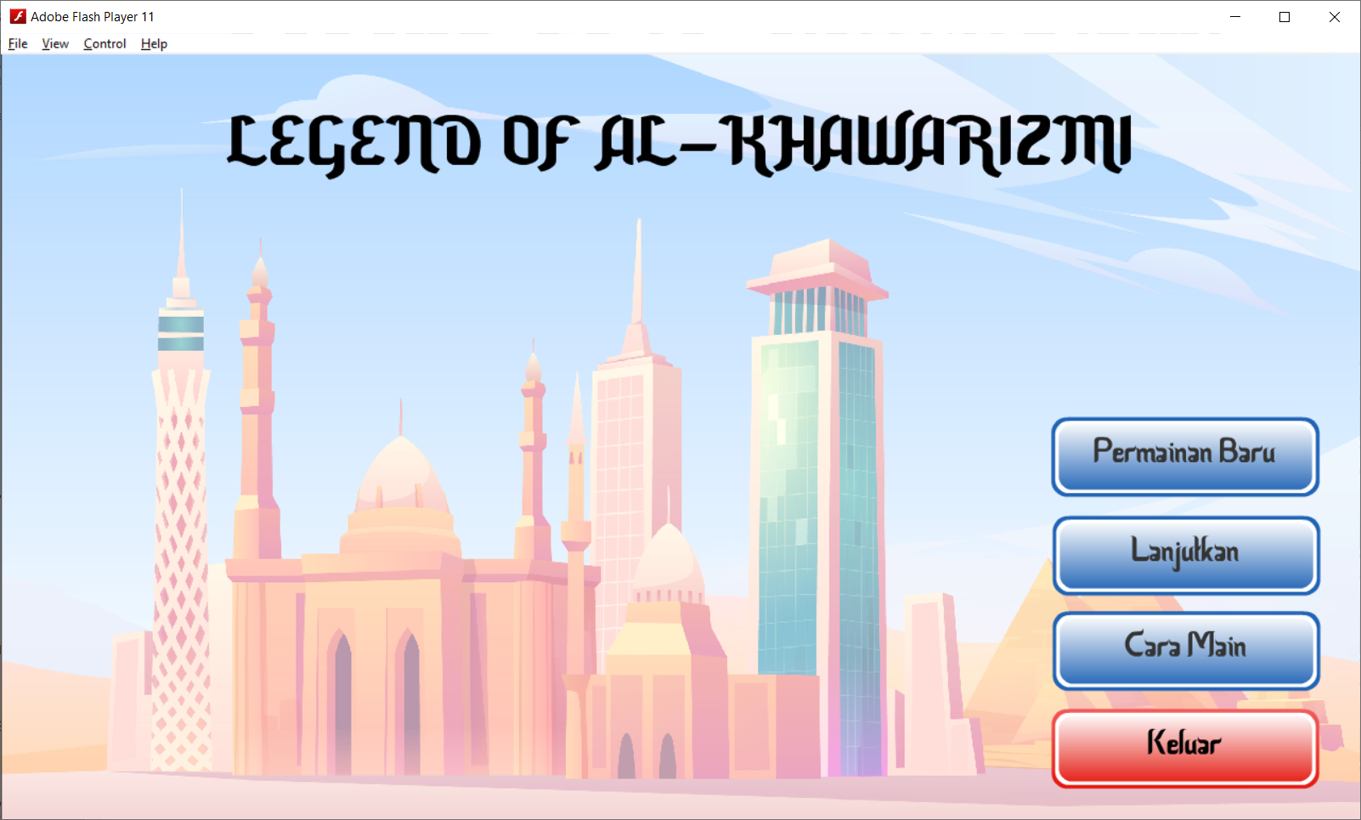

Gambar 3. Main Menu

|  |  |
| --- | --- |
|  |  |

Gambar 4. Scene Awal

|  |  |
| --- | --- |
|  |  |

Gambar 5. Scene Town-01 dan Town-02

|  |  |
| --- | --- |
|  |  |

Gambar 6. Scene Town-01 (Teori: Pengenalan Algoritma)

|  |  |
| --- | --- |
|  |  |

Gambar 7. Scene Town-02 (Praktikum: Tipe Data dalam Bahasa C)

|  |  |
| --- | --- |
|  |  |

Gambar 8. Scene Dungeon Town-01