
An Analysis The Cognitive Processes of Students in Solving Algebraic Numeracy Domain
Abstract
Problem-solving can be understood as a cognitive process in which students know facts, processes, concepts, and procedures and then apply the knowledge to solve problems in the context of real situations. The national average achievement of numeracy skills in 2021 in the cognitive process of reasoning is higher than the cognitive processes of knowing and applying. This study aims to analyze students' cognitive processes in solving numeration problems related to the algebraic domain. The algebraic domain in this study is limited to basic competencies in making generalizations from patterns in number sequences and object configuration sequences. This research was conducted qualitatively with a phenomenological design using three upper category students and three lower category students to achieve data saturation. The auxiliary instrument is in the form of student answers and interview results related to numeracy questions in the algebraic domain. This study concluded that students' cognitive processes in solving numeracy problems related to the algebraic domain in the upper and lower categories have different descriptions. This difference in intelligence has an impact when solving math problems. This research can help enrich the understanding of students' cognitive processes and contribute to the development of better mathematics learning strategies and curriculum.
Keywords: Cognitive Processes; Numeracy; Algebraic domain
How to cite: Kinanti, M. A. H., Sujadi I., & Kuncoro, K. S. (2023). An Analysis The Cognitive Processes of Students in Solving Algebraic Numeracy Domain. Jurnal Elemen, 9(1), 1-10. https://doi.org/10.29408/jel.v9i1.XXXX
Received: Date Month Year | Revised: Date Month Year
Accepted: Date Month Year | Published: Date Month Year

Introduction

The term "cognitive" refers to conscious mental processes, including remembering, reasoning, and knowing, as defined by Pantsar (2019). Montague et al. (2014) describe cognitive processes as proactive online mental activities, also known as "to do" strategies. These processes involve utilizing existing knowledge, integrating it with new knowledge, and using the resulting knowledge to make decisions, as described by Basir et al. (2022). Furthermore, cognitive processes pertain to an individual's mental processes, particularly concerning the view that the mind has internal mental states like beliefs, desires, and intentions, which can be understood through information processing. Ekawati et al. (2019) suggest that this is particularly true when dealing with complex cognitive processes, such as those involving abstraction, concretization, knowledge, expertise, or learning.)

According to Kurniadi et al. (2021), six components of cognitive processes are: mathematical communication, representational forms, mathematical problem solving, mathematical argumentation, modeling, and technical abilities and skills. Cognitive processes are necessary for each learner to receive, store, retrieve, and process data in relation to the process of solving mathematical problems (Fauziyah et al., 2022), which involves knowledge and one's cognitive system in the cognitive process to get solutions from a problem (Listiawan & Baskoro, 2015). Cognitive processes and mathematical problem solving are related, so problem solving can be understood as a cognitive process where students know facts, processes, concepts, and procedures and then apply this knowledge to solve problems in the context of real situations.

Previously, Fauziyah et al. (2022) reveal that differences in the intelligence of students with autism spectrum disorder (ASD) affect cognitive processes in solving problems based on the Polya procedure. Ekawati et al. (2019) reveal that cognitive processes in solving problems related to the concept of broad conservation in students with high abilities carry out more cyclic processes than students with low abilities. Kurniadi et al. (2021) explore and provide an overview of cognitive processes, especially using representational forms in mathematical modeling related to gender differences, where men and women solve graph problems using representative forms through three components of cognitive processes. Hayuningrat and Listiawan (2018) describe students' thinking processes with a cognitive-reflective style in solving pattern generalization problems based on Polya measurements. Based on several studies regarding cognitive processes that have been carried out previously, there is still no one who discusses students' cognitive processes related to solving algebraic domain numeration problems.

The Organization for Economic Cooperation and Development (OECD) defines numeracy as the ability to develop, apply, and interpret mathematics in various circumstances. Getenet (2022) suggests that numeracy is the effective application of mathematics to meet the needs of everyday life at home, at work, and for involvement in social life. The ability of adults to successfully participate in society and manage work in everyday life depends on their ability to use and develop their numeracy skills (Gal et al., 2003). Every child must have numerical thinking skills, an understanding of patterns and sequences, and the ability to identify situations where mathematical reasoning can be used to solve problems (DES, 2011). Numerical ability is one of the prerequisites for realizing 21st century life skills (Sujadi et al., 2022), so numeracy is very important to learn as early as possible

The concept of numeracy in Indonesia includes aspects of cognitive processes, contexts, and domains. Numerical abilities require students to use various cognitive skills in answering questions (Lestari et al., 2022). The cognitive process in the Minimum Competency Assessment is divided into three parts: knowing, applying, and reasoning. The cognitive knowing process assesses basic knowledge and understanding of facts, processes, concepts, and procedures. The cognitive applying process assesses mathematical abilities in applying knowledge and understanding of facts, relations, processes, concepts, procedures, and methods in the context of real-life situations to solve problems and answer questions. The cognitive reasoning process assesses reasoning abilities in analyzing informational data, drawing conclusions, and expanding understanding in new situations. The AKM 2022 framework categorizes the context in numeration of three types: personal, socio-cultural, and scientific. The domains in the Minimum Competency Assessment refer to the PISA content domains, namely numbers, geometry, and measurement, algebra, as well as data and uncertainty.

The Education Report Card 2022, nationally, shows that more than 50% of junior high school students in Indonesia have not reached the minimum competency limit for numeracy skills. Based on the results of the Minimum Competency Assessment in the 2021 Education Report Card, the average national numeracy achievement at the reasoning competency is 54.72, higher than knowing competence (54.65) and applying (50.9). In fact, student understanding plays an important role in reasoning abilities (Gonc, et al., 2017). Mullis and Martin (2017) suggest that an individual needs to identify relevant mathematical concepts or procedures to solve problems in new contexts or situations. Understanding of mathematical concepts and procedures becomes a bridge in the application of mathematics to solve problems in various contexts and situations. Based on this understanding, the cognitive process of reasoning is influenced by the previous cognitive processes, namely knowing and applying. Academically, the percentage of cognitive reasoning processes should be smaller than the percentage of knowing and applying cognitive processes.

Based on the explanation above, the analysis of cognitive processes in solving numeracy problems can be a reference for teachers, the government, and further research in order to determine the right strategy to complement deficiencies or overcome student obstacles. Cognitive process analysis really needs to be done to support the evaluation program of the existing education system in Indonesia. Cognitive process analysis in solving numeracy problems can be used as information on students' basic competencies in solving problems in a domain. The cognitive processes in this study are focused on knowing cognitive processes, applying cognitive processes, and cognitive reasoning processes. This research is focused on the algebraic domain because, based on the opinion of Sujadi et al. (2022), one of the most difficult questions is the content of change and relationships related to algebraic material. This study aims to analyze students' cognitive processes in solving numeration problems related to the algebraic domain.

Methods
This research was conducted to answer how students' cognitive processes relate solving numeracy problems in the algebraic domain. Qualitative research was chosen as an alternative approach for conducting this research. Qualitative methods allow researchers to understand more deeply the cognitive processes involved in solving algebraic numeracy problems. By interviewing respondents and observing their actions directly, researchers can gain a deeper understanding of how students think and solve math problems. Qualitative methods also allow researchers to study individual experiences in solving algebraic-numeracy problems.
In this study, researchers can study how students with different backgrounds solve math problems so that they can provide richer and more holistic insights about the observed phenomena. Phenomenological research is a design of inquiry coming from philosophy and psychology in which the researchers describe the lived experiences of individuals about a phenomenon as described by participants (Creswell, 2014). The phenomenological design allows researchers to explore students' experiences in solving numeration problems in the algebraic domain, including how students construct knowledge, understand related concepts, and use strategies to solve numeration problems. As a study of the meaning and significance of a phenomenon, the researchers use the source triangulation technique. Triangulation of this source as a form of triangulation is necessary so that the results obtained are not subjective.
Researchers, as key instruments, fully control the entire research process. In addition, researchers also used auxiliary instruments in the form of student answers and interview results related to numeracy questions in the algebraic domain. The algebraic domain in this study is limited to basic competencies in making generalizations from patterns in number sequences and object configuration sequences. Descriptions of cognitive process indicators in the numeration questions above are presented in Table 1.
Table 1. Description of the cognitive process of numeration questions
Cognitive Process | Aspect | Indicator
Knowing | Remembering | Remember the concept of pattern sequence numbers
Knowing | Understanding | Understand the facts on number patterns
Knowing | Identifying | Identify what elements are used in the number sequence pattern.
Knowing | Counting | Count the number of elements in a particular set of patterns
Applying | Making model | Make a model of the number of beads in a certain series
Applying | Applying | Implement the model that has been created
Reasoning | Making justification / analyzing | Provide an explanation based on the opinions that have been given
Reasoning | Concluding | Summarize the results of the analysis that has been made

The suitability of the items with the indicators to be measured was evaluated by two validators, and it was stated that the instrument could be used. On the other hand, the interview guide is used as a reference for conducting in-depth interviews with research subjects to confirm the results of student work. Data were collected by means of tests and interviews with six research subjects from class VIII at one of the public middle schools in Karanganyar Regency. Selecting a small number of research subjects allows the researcher to gain a deeper understanding of students' cognitive processes in solving algebraic domain numeration problems. By only focusing on a few research subjects, researchers can obtain more detailed and in-depth information about each individual being observed. The six subjects had previously been categorized into two categories based on the KKM score. Students with a score of more than 70 are included in the upper category, while students with a score of less than 70 are included in the lower category.
The subject of each category was selected based on a purposive sampling technique. The purposive sampling technique allows researchers to choose research subjects that are most relevant to the research topic, so they can obtain richer and more useful data. In this study, researchers were able to select students who have different levels of mathematical ability to study the cognitive processes involved in solving algebraic numeracy problems. It takes three upper category subjects and three lower category subjects to achieve data saturation. while the data analysis technique refers to Miles and Huberman (2014), including (1) data condensation, (2) data display, and (3) conclusion drawing/verification.

Results
The numerical questions used consist of one stimulus with three questions representing different cognitive processes, as presented in Figure 1.
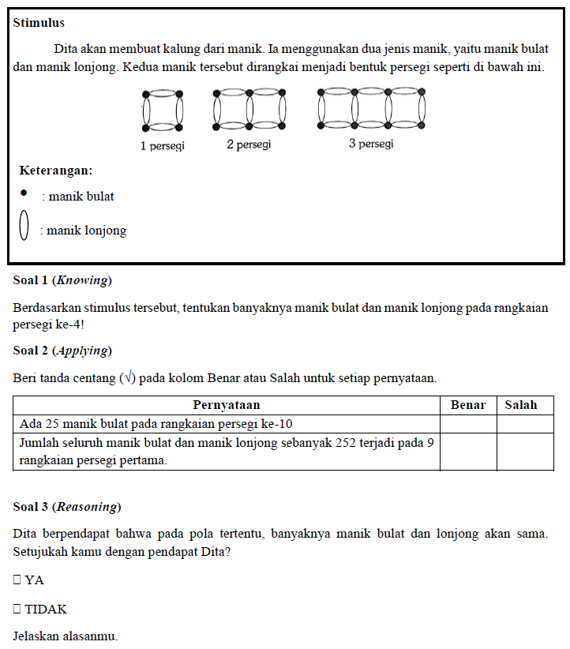
Figure 1. Numeracy problems

The numeracy questions used in this study were compiled based on a cognitive process that consisted of the cognitive processes of knowing, applying, and reasoning. Question number 1 describes the cognitive process of knowing, item number 2 describes the cognitive process of applying; and question number 3 describes the cognitive process of reasoning. The results of the analysis of the cognitive processes of students in the upper and lower categories in solving algebraic domain numeration problems are as follows.

Upper Category Cognitive Process
The upper category consists of three subjects, namely S₁, S₂ and S₃. The results of the upper category cognitive process analysis are based on the data of each upper category subject obtained from the answers and subject interviews. The analysis presented is the result of the overall analysis according to each cognitive process as follows.
The Cognitive Process of Knowing
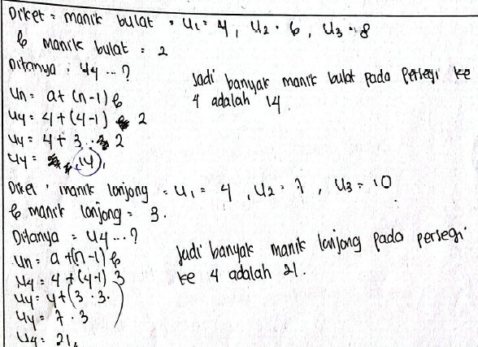  (a) | 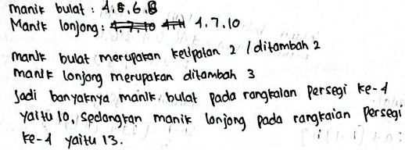  (b) | 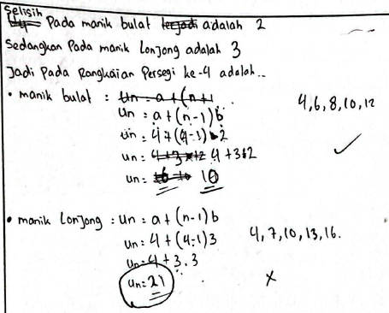  (c)
Figure 2. (a) Answer to question number 1 S₁; (b) Answer to question number 1 S₂; (c) Answer to question number 1 S₃
Two of the three subjects in the upper category knew that the numeration task was related to the matter of number sequence patterns. "The material is a number pattern because there is a pattern," explained the subject when asked why the material is a number pattern. Two of the three subjects in the upper group know that difference has the symbol b, the first term has the symbol a, and the n^{th} term has the symbol $S_{n}$. S₁ counts the number of beads in the 4th square series using the formula (see Figure 2(a)), S₂ uses the manual method, by adding up to the 4th term (see Figure 2(b)), and S₃ uses two methods, namely the formula and the manual method (see Figure 2(c)).
The Cognitive Process of Applying
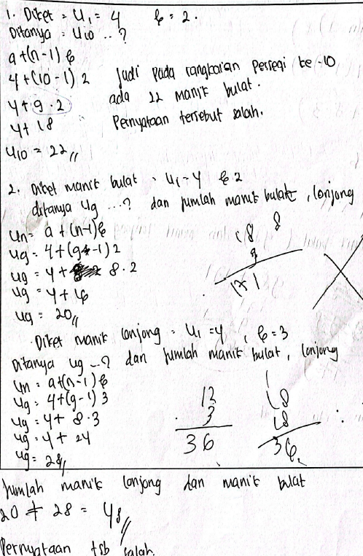  (a) | 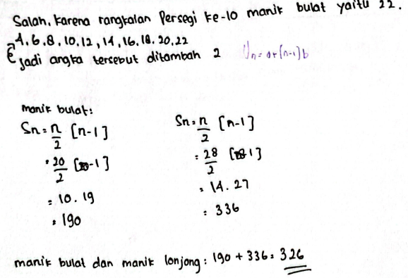  (b) | 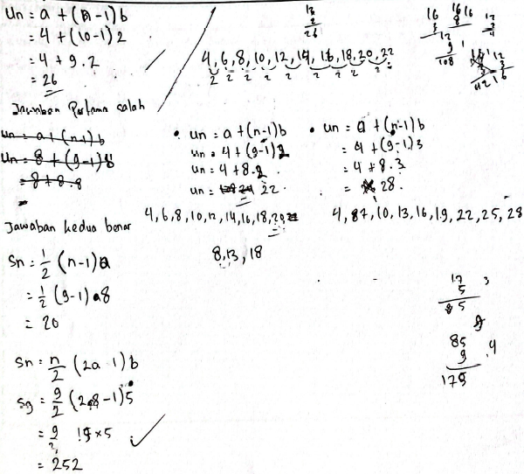  (c)
Figure 3. (a) Answer to question number 2 S₁; (b) Answer to question number 2 S₂; (c) Answer to question number 2 S₃
In the first statement, the three subjects in the upper group answered incorrectly (see Figure 3), where two of the three subjects checked the statement using the arithmetic sequence formula to find the 10th term, but the subject did not prioritize the multiplication operation so that the 10th term found was incorrect. S₂ uses the manual method in Figure 3(b), and the 10th term found is correct, but this becomes difficult if the asked term is larger, for example the 50th term. "I forgot the formula, so I did it manually," explained the subject during the interview.
In the second statement, two of the three subjects in the upper group knew that to check this statement, it is necessary to use an arithmetic series formula, but the formula used is incorrect, so the mathematical model is wrong. Two of the three subjects in the upper group applied the arithmetic series formula to the beads separately, namely by calculating $S_{n}$ round beads and $S_{n}$ oval beads separately, then combining them. "It means 108 round beads, 144 oval beads, a total of 252 pieces, so the second statement is true," explained the subject during the interview.
The Cognitive Process of Reasoning
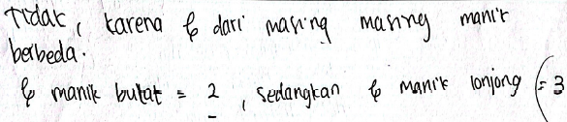
(a)

(b)
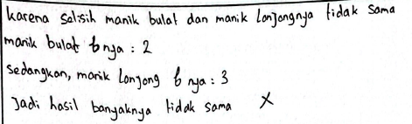
(c)
Figure 4. (a) Answer to question number 3 S₁; (b) Answer to question number 3 S₂; (c) Answer to question number 3 S₃
Two of the three subjects in the upper group answered disagree based on the results of the analysis that the differences in each bead were not the same; round beads had a difference of 2, while oval beads had a difference of 3 (see Figure 4). "The difference is that each bead is not the same, round beads are two different, oval beads are three different, one is odd, and the other is even," explained the subject during the interview. The three subjects were unsure of their respective answers, because they did not understand the meaning of the statement.

Lower Category Cognitive Processes
The lower category consists of three subjects namely S₄, S₅ and S₆. The results of the analysis of lower category cognitive processes are based on the data of each lower category subject obtained from answers and subject interviews. The analysis presented is the result of the overall analysis according to each cognitive process as follows.
The Cognitive Process of Knowing

(a)

(b)
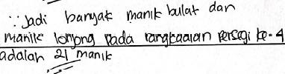
(c)
Figure 5. (a) Answer to question number 1 S₄; (b) Answer to question number 1 S₅; (c) Answer to question number 1 S₆

"I've forgotten the number pattern material", explained two of the three subjects in the lower group who did not know that the material related to the problem is a number pattern. Regarding the facts in number patterns such as the first term, difference, and n^{th} term, two of the three lower group subjects did not know that the symbol a was the first term, the difference had the symbol b and $U_{n}$ was the symbol of the n^{th} term. The subject did not know how to look for differences, so this was influential in answering question number 1 (see Figure 5).
Based on the low understanding of facts in number patterns, two out of three subjects did not know how to find the fourth term. Subjects need to be given an understanding in advance, that round beads and oval beads have a repeated addition pattern, so that to find beads in the fourth series, the pattern found in round and oval beads is needed.
The Cognitive Process of Applying

(a)

(b)
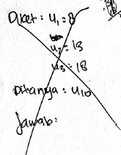
(c)
Figure 6. (a) Answer to question number 2 S₄; (b) Answer to question number 2 S₅; (c) Answer to question number 2 S₆
In the first statement, two of the three subjects in the lower group answered the wrong statement, where one of the subjects used a manual method to check the statement. Two of the three subjects only ticked the statements and did not attempt to answer manually (see Figure 6). The three subjects did not know how to check this statement using the formula for the n^{th} term of the arithmetic sequence. In the second statement, the three subjects did not know the reason that the formula used to check the statement was an arithmetic series $S_{n}$, because they were only guessing. "I'm just guessing because I forget the formula," explained the subject during the interview. The three subjects did not know what formula to use, so when asked, they did not know at all. The three subjects had no idea how to answer the second statement. After being given the formula, the three subjects were able to correctly count the total number of beads. The three subjects need to be given guidance regarding which sequence to use so that they can combine round and oval beads and form a new number sequence.
The Cognitive Process of Reasoning

(a)

(b)

(c)
Figure 7. (a) Answer to question number 3 S₄; (b) Answer to question number 3 S₅; (c) Answer to question number 3 S₆
In the third statement, two out of the three lower groups agreed with the opinion. The subjects thought that round and oval beads would be the same when strung together into a square shape (see Figure 7(a)). The subjects did not understand the meaning of a certain pattern in the statement. The three subjects were not sure about the results of their analysis because they did not understand the meaning of the questions.

Discussion
This study describes the stages of the cognitive process referring to the AKM carried out by students in solving algebraic numeracy problems. This can help understand the difficulties experienced by students in solving algebraic numeracy problems, as well as provide a deeper view of the cognitive strategies used by students in solving problems. The cognitive process of knowing in the algebraic domain consists of aspects of remembering, understanding, identifying, and calculating (AKM Framework, 2022). The cognitive process of applying to the algebraic domain includes aspects of modeling and applying. The cognitive process of reasoning in this study consists of two aspects, namely making justification/analyzing and concluding.
The results of the description of students' cognitive processes in the upper category are that, in the cognitive process of knowing, students remembered the material of number patterns where the concepts explained are only in general, understood the facts of number patterns (a, b, and $U_{n}$), identified how to look for differences, the first term, and the n^{th} term, as well as counting, but students did not prioritize multiplication operations. In the cognitive process of applying, students could make a model according to the numeration task after being told the formula, then apply the model that had been made. In the aspect of making a model, the subject experienced difficulties because he forgot the formula, so he could not solve the problem (Zebua, 2020). After being given the arithmetic series formula, the three subjects could make a model and apply the model that had been made. In the process of implementing this, the subject did not prioritize multiplication operations. This error continued to occur, supported by students' lack of mastery of the material (Yulianingsih & Dwinata, 2018). The results of research on the cognitive process of reasoning show that students had difficulty analyzing, and the conclusions explained are not appropriate. The subject is used to working on problems that have a formula, so when faced with a problem that requires reasoning, the subject becomes confused. In addition, the subject did not interpret daily conditions through story problem exercises, so it was difficult when faced with problems that required reasoning (Sartika &; Puspitasari, 2013).
The results of students' cognitive processes are in the lower category; in the cognitive process of knowing, students did not remember the concept of number patterns. In fact, mathematical understanding is an important basis for thinking when solving mathematical problems and real-life problems (Mulyani et al., 2018). Lower category subjects had difficulty stating facts in numerical patterns and only wrote down the final answer on paper. This is in line with many students who have difficulty understanding mathematical symbols, writing down what they think in solving problems, predicting, and making decisions (Irfan, 2017; Boyer, 2008; Siswono, 2016; Winata et al., 2021). Students are unable to work because they do not know the procedure used to solve the problem (Septiahani, 2020). Subjects are not used to changing contextual problems in number patterns into sequences, so they are confused when remembering the concept of number sequence patterns. The subject is unable to interpret the meaning of the words or terms in the questions (Septiahani, 2020). In the cognitive process of applying, students need to be told the formula, then they can apply it independently. Lack of understanding of concepts related to number sequence patterns causes subjects in the lower category to not know that the problem can be solved by adding manually (Kania, 2018). When the subject is told the formula on how to find the n^{th} term, the subject can continue the next calculation process. Students are not able to analyze the questions in the questions, so the answers are given soberly (Hutajulu, 2019). Subjects in the lower category still need a companion to provide a formula so they can solve the problem. The results of research on the cognitive process of reasoning show that students have difficulty analyzing, and the conclusions that are drawn are not appropriate. This could be due to the fact that from the beginning, the students didn’t have a sufficient understanding of the concept of number sequence patterns, making it increasingly difficult for them to analyze and reason through the problem.
Based on the results of student work and interviews, it is known that several factors influence students' cognitive processes in solving numeracy problems in the algebraic domain, such as mastery of concepts, numeracy skills, and motivation to learn. Isnarto (2016) suggests that problem solving requires the ability to understand problems, identify concepts, find generalizations, make plans, and then organize previous skills. This can help teachers develop effective learning strategies to help students overcome difficulties encountered in solving algebraic numeracy problems. Teachers can conduct briefings, recall mathematical concepts, carry out exercises to train students' numeracy skills (Anggraini & Setianingsih, 2022). The implications of this research for learning mathematics in schools are that teachers can use the results of this research to develop more effective learning strategies, such as providing more structured subject matter and providing opportunities to practice solving numeracy problems in the algebraic domain. In this case, this research can help improve students' ability to solve numeracy problems in the algebraic domain and strengthen mathematics learning in schools.
Finally, the results of this study can also provide implications for further research in the field of mathematics education. Researchers can use the results of this study as a basis for conducting further research on students' cognitive processes in solving algebraic numeracy problems, as well as exploring other factors that influence students' ability to solve mathematical problems. This research can also enrich students' understanding of cognitive processes and contribute to the development of better mathematics learning strategies and curriculum.

Conclusion
This study concludes from the results of the description of students' cognitive processes in the upper category that, in the cognitive process of knowing, students remember the number pattern material where the concepts explained are less specific. Students understand the facts of number patterns (a, b, and $U_{n}$), identify how to find differences, the first term and the n^{th} term, and count, but students do not prioritize multiplication operations. In the cognitive process of applying, students can create and apply models according to the numeration task after being told the formula. The results of the students' cognitive processes who are in the lower category, that in the cognitive process of knowing, students do not remember the concept of number patterns. Students mention and identify several facts in number patterns, and counting needs to be assisted because they have forgotten the number pattern material. In the cognitive process of applying, students need to be told the formula, then they can apply it independently. The results of research on the cognitive process of reasoning in the upper and lower categories showed that students had difficulty analyzing and concluding because they did not understand the meaning of the numeration questions.

This study concluded that students' cognitive processes in solving numeracy problems related to the algebraic domain in the upper and lower categories have different descriptions. This difference in intelligence has an impact when solving math problems. This can be seen based on the results of the numeration assignments and direct interviews with each student. This study also concludes that there is a need to increase students' understanding of algebraic concepts and appropriate strategies for solving numeracy problems in the cognitive processes of knowing, applying, and reasoning.

Conflicts of Interest

There is no conflict of interest regarding the publication of this manuscript.

Funding Statement
This work received no specific grant from any public, commercial, or not-for-profit funding agency.

References
Anggraini, K. E. & Setianingsih, R. (2022). Analisis Kemampuan Numerasi Siswa SMA dalam Menyelesaikan Soal Asesmen Kompetensi Minimun (AKM). MATHedunesa, 11(3), 837-849. https://doi.org/10.26740/mathedunesa.v11n3.p837-849
Basir, M. A., Waluya, S. B., Dwijanto & Isnarto. (2022). How Students Use Cognitive Structures to Process Information in the Algebraic Reasoning. European Journal of Educational Research, 11(2), 821-836. https://doi.org/10.12973/eu-jer.11.2.821
Creswell, J. W. (2014). Research Design: Qualitative, Quantitative and Mixed Methods Approahes. California: SAGE Publications.
DES. (2011). Literacy and numeracy for learning and life. Department of Education and Skills. Dublin: Whitechurch National School. http://www.education.ie/en/publications/policy-reports/lit_num_strategy_full.pdf.
Ekawati, R., Kohar, A. W., Imah, E. M., Amin, S. M., & Fiangga, S. (2019). Students’ Cognitive Processes in Solving Problem Related to the Concept of Area Conservation. Journal on Mathematics Education, 10(1), 21-36. https://doi.org/10.22342/jme.10.1.6339.21-36
Fauziyah, N., Budayasa, I. K., & Juniati, D. (2022). Cognition Processes of ASD Students: Recommendations for Mathematics Teaching and Learning Processes. International Journal of Instruction, 15(3), 805-830. https://doi.org/10.29333/iji.2022.15344a
Getenet, S. T. (2022). Teachers‘ knowledge framework for designing numeracy rich tasks across non-mathematics curriculum areas. International Journal of Education in Mathematics, Science, and Technology (IJEMST), 10(3), 663-680. https://doi.org/10.46328/ijemst.2137
Hayuningrat, S., & Listiawan, T. (2018). Proses Berpikir Siswa dengan Gaya Kognitif Reflektif dalam Memecahkan Masalah Matematika Generalisasi Pola. Jurnal Elemen, 4(2), 183-196. https://doi.org/10.29408/jel.v4i2.752
Hendriana, H, Rohaeti E. E, & Sumarmo, U. (2017). Hard Skills dan Soft Skills Matematika Siswa. Bandung: Refika Aditama.
Hutajulu, M., Senjayawati, E., & Minarti, E. D. (2019). Analisis Kesalahan Siswa SMK Dalam Menyelesaikan Soal Kecakapan Matematis Pada Materi Bangun Ruang. Mosharafa: Jurnal Pendidikan Matematika, 8(3), 365-376. https://doi.org/10.31980/mosharafa.v8i3.505
Irfan, M. (2017). Bentuk a/b: Sebagai Pecahan, Pembagian, atau Perbandingan?. Jurnal Penelitian Pendidikan dan Pengajaran Matematika (JP3M), 1(4). https://doi.org/10.37058/jp3m.v3i1.201
Isnarto, M. M. L. (2016). Analisis Kemampuan Pemecahan Masalah Ditinjau Dari Karakteristik Cara Berpikir Siswa Dalam Model Problem Based Learning. Unnes: Journal of Mathematics Education, 5(1). https://doi.org/10.15294/ujme.v5i1.9343
Kania, N. (2018). Analisis Kesalahan Mahasiswa PGSD dalam Menyelesaikan Soal Pemecahan Masalah Matematis Berdasarkan George Polya. Eduma:Mathematics Education Learning and Teaching, 7(1), 19–39. http://dx.doi.org/10.24235/eduma.v7i1.2711
Kurniadi, E., Sari, N., & Darmawijoyo. (2021). Cognitive Processes of Using Representational Form in Mathematical Modelling Based on Gender Differences. Jurnal Elemen, 7(2), 463-474. https://doi.org/10.29408/jel.v7i2.3627
Lestari, S., Waluya B., & Dewi, N. R. (2022). Kemampuan Penalaran Matematis Siswa SMK dalam Model Pembelajaran Treffinger Berbasis Filosofi Pemikiran Ki Hadjar Dewantara. Jurnal Ilmiah Pendidikan Matematika, 7(2), 113-121. https://doi.org/10.26877/jipmat.v7i2.12057
Listiawan, T., & Baskoro, W. W. (2015). Analisis Technological Content Knowledge (TCK) calon guru matematika dalam menggunakan perangkat lunak geometri dinamis. In Seminar Nasional Matematika dan Pendidikan Matematika, 827–834. http://dx.doi.org/10.13140/RG.2.1.4443.3522
Miles, M. B., Huberman, A. M., & Saldana, J. (2014). Cross-case data analysis. In Qualitative data analysis: An expanded sourcebook. California: SAGE Publications
Montague, M., Warger, C., & Morgan, T. H. (2000). Solve it! Strategy Instruction to Improve Mathematical Problem Solving. Learning Disabilities Research & Practice, 15(2), 110-116. https://doi.org/10.1207/SLDRP1502_7
Mullis, I. V. S. & Martin, M. O. (2017). TIMSS 2019 Assessment Framework. Chestnut Hill: International Association for the Evaluation of Educational Achievement (IEA).
Mulyani, A., Indah, E. K. N., & Satria, A. P. (2018). Analisis Kemampuan Pemahaman Matematis Siswa SMP pada Materi Bentuk Aljabar. Jurnal Mosharafa, 7(2), 251-261. https://doi.org/10.31980/mosharafa.v7i2.24
Organisation for Economic Co- operation and development [OECD]. (2012). Literacy, numeracy and problem solving in technology- rich environments: Framework for the OECD survey of adult skills. OECD publishing. https://www.oecd-ilibrary.org/education/literacy-numeracy-and-problem-solving-in-technology-rich-environments_9789264128859-en
Pantsar, M. (2019). Cognitive and Computational Complexity: Considerations from Mathematical Problem Solving. Erkenntnis, 961-997. https://doi.org/10.1007/s10670-019-00140-3
Sartika, G. P., & Puspitasari, N. (2013). Perbedaan Kemampuan Komunikasi Matematik siswa antara yang Mendapatkan Model Pembelajaran Student Teams Achievement Divisions dengan Model Pembelajaran guided Note Taking. Mosharafa: Jurnal Pendidikan Matematika, 2(2), 87-98
Septiahani, A., Melisari., & Zanthy, L. S. (2020). Analisis Kesalahan Siswa SMK dalam Menyelesaikan Soal Materi Barisan dan Deret. Mosharafa: Jurnal Pendidikan Matematika, 9(2), 311-322. https://doi.org/10.31980/mosharafa.v9i2.644
Siswono, T. Y. E. (2016). Proses Berpikir Kreatif Siswa Dalam Memecahkan dan Mengajukan Masalah Matematika. Jurnal Ilmu Pendidikan, 15(1). http://dx.doi.org/10.17977/jip.v15i1.13
Sujadi, I., Budiyono, Kurniawati, I., Wulandari, A. N., Andriatna, R., & Puteri, H. A. (2022). Pengantar Kemampuan Numerasi. Yuma Pustaka: Surakarta.
Wijaya, A. & Dewayani, S. (2021). Framework Asesmen Kompetensi Minimum (AKM). Pusat Asesmen dan Pembelajaran, Badan Litbang dan Perbukuan, Kemendikbud.
Winata, A., Widiyanti, I. S. R., & Cacik, S. (2021). Analisis Kemampuan Numerasi dalam Pengembangan Soal Asesmen Kemampuan Minimal pada Siswa Kelas XI SMA untuk Menyelesaikan Permasalahan Science. Jurnal Educatio, 7(2), 498-508. https://doi.org/10.31949/educatio.v7i2.1090
Yulianingsih, A., & Dwinata, A. (2018). Analisis Kesalahan Konsep Pecahan pada Siswa Kelas VII A SMP Negeri 13 Satu Atap Tanjungpinang. Mosharafa: Jurnal Pendidikan Matematika, 7(2), 199–206. https://doi.org/10.31980/mosharafa.v7i2.22
Zebua, V., Rahmi, & Yusri, R. (2020). Analisis Kesalahan Siswa dalam Menyelesaikan Soal Barisan dan Deret Ditinjau dari Kemampuan Pemahaman Konsep Matematis. Lemma: Letters Of Mathematics Education, 6(2), 122-133. http://dx.doi.org/10.22202/jl.2020.v6i2.4088

