Teaching Skills of Prospective Mathematics Education Teachers in Microteaching Subjects: Commognitive Perspective

Moh Zayyadi¹, Toto Nusantara²
¹University of Madura, Pamekasan, Indonesia
²State University of Malang, East Java, Indonesia
*zayyadi@unira.ac.id

Abstrak
Tujuan dari penelitian ini adalah untuk mendeskripsikan keterampilan mengajar calon guru Pendidikan Matematika pada mata pelajaran micro teaching dalam perspektif kognitif. Jenis penelitian ini adalah penelitian kualitatif. Subjek penelitian terdiri dari lima belas orang mahasiswa Program Studi Pendidikan Matematika angkatan 2015 yang sedang menempuh mata kuliah micro teaching. Instrumen yang digunakan dalam penelitian ini antara lain lembar rubrik, penilaian keterampilan mengajar calon guru dan rubrik silabus Nilai. Teknik analisis data yang digunakan adalah reduksi data, penyajian data, dan pengumpulan kesimpulan. Hasil penelitian menunjukkan bahwa: Calon guru pendidikan matematika pada kegiatan pendahuluan lebih sering menggunakan komponen word use, visual mediator, routine, dan tidak menggunakan komponen narrative. Dalam kegiatan inti pembelajaran calon guru matematika menggunakan 4 komponen kognitif yaitu word use, visual mediator, routine dan narrative. Dalam pemilihannya, calon guru pendidikan matematika hanya menggunakan komponen word use.
Kata kunci: Commognitive, Microteaching, Kemampuan mengajar

Abstract
The purpose of this study is to describe the teaching skills of prospective mathematics education teachers in micro teaching subjects in a commognitive perspective. This type of research is qualitative research. The research subjects consisted of 15 students of the 2015 class of Mathematics Education Study Program which were taking micro teaching courses. The instrument used in this study was a rubric sheet. Assessment of prospective teacher's teaching skills and rubric sylabus Value. Data analysis techniques used are data reduction, data presentation, and conclusion collection. The results showed that: Prospective mathematics education teachers in preliminary activities more often use the word usage component, visual mediator, routine and do not use the narrative component. In the core activities of learning mathematics teacher candidates use 4 components commognitive which are the use words, visual mediators, routine, and narrative. In the selection of mathematics education teacher candidates only use the word use component.
Keywords: Commognitive, Microteaching, Teaching skills

Received: August 17, 2019 / Accepted: November 21, 2019 / Published Online: January 31, 2020

Introduction
Learning with micro teaching is still widely practiced by several universities in Indonesia in providing experience and knowledge in the teaching process for prospective teacher students. Microteaching learning is a recorded and practical implementation system that applies during the teaching process under controlled conditions and focuses on teaching skills (Kazu, 1996]. In addition, micro-education is believed to consist of controlled elements, microteaching prepares prospective teachers in teaching practices and the teaching profession (Hiebert, dkk., 2003). Micro teaching is a cycle in which prospective teachers plan lessons that focus on specific subjects and present lessons in 10-15 minutes to 10-15 with classmates and instructor instructors and recorded on video (Bilen, 201). In this study, micro teaching is meant a system that controls all forms of teaching conducted by prospective teacher students with students being friends and a lecturer as a supervisor. Micro teaching is expected to prepare prospective teachers in carrying out actual teaching.
Micro-teaching learning is expected to be able to help prospective teacher students in giving the experience of being actual teachers in the class so that they are able to adapt in teaching. Micro teaching is thought to provide a transition period for preparing the environment in classroom learning (Külahçı, 1994). Mirco teaching learning can provide benefits in solving problems related to preparing, presenting and applying lessons (Kazu, 1996).
One research framework that can provide teacher teaching information in learning mathematics is commognitive. Investigates teaching practices carried out by mathematics teachers in three categories namely, providing explanations, motivations and asking questions (Viirman, 2015). Investigates mathematics teacher teaching practices on basic differential material (Tasara, 2017). Investigates being able to provide pre-service teacher teaching information in achieving mathematics teaching goals using a commognitive framework (Tuset, 2018). The process of solving mathematical problems of middle school studentsbase on commognitive (Zayyadi, dkk., 2019). Commognitive can have an impact on the professional development of prospective teachers in increasing students' exploratory participation in elementary and secondary schools (Metzuyanim & Tabach, 2017). In addition, commognitive has also been used to examine teacher discourse about teaching, including teacher professional identity and mathematical discourse (Metzuyanim & Tabach, 2017).

Methods
This type of research is descriptive qualitative research. The subjects of this study consisted of 10 students from the 2015 Class of Mathematics Education Study Program at Madura University. The instrument used was an observation sheet on the teaching skills of prospective teachers and a lesson plan (RPP). The data analyzed are video data from the implementation of the teaching skills of prospective teachers when implementing microteaching and lesson plans (RPP) made by prospective teacher students. Data analysis techniques used in this study are data reduction, data presentation, and drawing conclusions.
The analysis of the research conducted was an analysis of the teaching skills of prospective mathematics teachers in micro teaching subjects. The students' activities in learning this research are described as follows:
Table 1.The students' activities in learning
No | The students' activities in learning
1 | Preliminary activities
1 | - Prepare students mentally and physically
1 | - Apperception and provide motivation
1 | - Convey learning objectives
1 | - Convey the scope of the material
2 | Core activities
2 | - Delivering material,
2 | - Application of the concept of learning materials to life
2 | - Implementing learning strategies
2 | - Using learning media
2 | - Implementing classroom management
2 | - Involving students in learning
2 | - Conducting assessments in learning.
3 | Closing activities
3 | - Summarizing learning material a
3 | - Reflecting on learning

Results
The results section contains data exposure and research findings about the commognitive component of prospective teacher students when implementing classroom learning based on content knowledge and pedagogical knowledge.
3.1 Preliminary activities
In the learning activities, students carry out several steps of learning to prepare students mentally and physically as figure 1, apperception and provide motivation, convey learning objectives, and convey the scope of the material. The activity looks like below:
Subject: Assalamu Alaikum Children
Student: Wa'alaikumsalam mother
Subject: How are you today?
Student: Yes Sir
Subject: Have you had lunch?
Student: Not yet
Subject: Before we start the lesson today, it would be better for us to pray first so that the knowledge we gain is useful for us and for others
Student: Yes Sir
Subject: To the class leader to lead the prayer, sister Dinda
Student 1: Before we learn, let us pray first according to each other's beliefs start (Teacher and Students pray)
Student: Finish
Subject: Okay, Mother was absent beforehand, did anyone not attend today? (The teacher checks the presence of students) as Figure 1.
Student: There is sir
Subject: Who
Student: Sofia, it hurts
Subject: What pain?
Student: Mother, I have a fever
Subject: Okay at this meeting we will discuss about the equation of the absolute value of linear variables, does anyone know what is the equation of the linear absolute value of one variable?
Student: Don't know Sir,
Student: The value is always positive, yes and the variable is not one
Subject: Yes, then someone knows again
Student: If there is absolute brackets like that, right?
Student: Okey, Sir
Subject: So the equation of the linear absolute value of one variable is an equation that involves absolute value with a variable that has the highest rank of one. That is called the equation of the linear absolute value of one variable.
Student: Yes Mom.
Subject: Our first learning goal today is to understand and identify the absolute value equation
from the linear form of one variable. The second goal is to solve the problem of the absolute value equation of the linear form of one variable.
Student: Yes
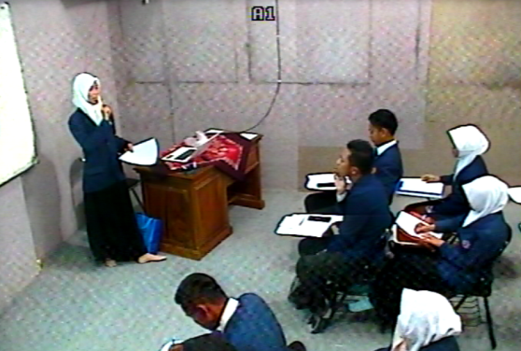

Figure 1. Subject prepares students mentally and physically
The use of the word use component in preliminary activities is to prepare students mentally and physically, "Before we start the lesson today, it would be better for us to pray first so that the knowledge we gain is useful for us and for others", do apperception and provide motivation to convey learning objectives, "Our learning goal today is first to understand and identify the absolute value equation from the linear form of one variable." and deliver the scope of the material "Okay at this meeting we will discuss about the equation of absolute linear value one variable, does anyone know what is the linear absolute value equation of one variable? ". In the preliminary activities, word use that is done by the subject is with mathematical terms, colloquial words and other mathematical terms as key words in accordance with the material being taught and word use is used as a keyword and initial information is given to students in accordance with the material to be taught. This is in accordance with the statement that the word use used in mathematical discourse includes specific words (certain words) (Mosvold, 2016). In addition, word use in this study as words used in interpreting mathematical material. This is consistent with the statement that words are commonly used with mathematical meanings (Sfard, 2008).

  - Core activities
In the core activities, students carry out several steps of learning such as delivering material, implementing learning strategies, using learning media, implementing classroom management, involving students in learning as Figure 2, and conducting assessments in learning. The activity looks like below:

Subject: Here the mother uses the STAD learning method. Alright mom will make you into groups here group 1 this is group 2 yes (teacher divides students into 2 groups)
Student: Yes ma’am
Subject: Mother will give a Student Worksheet to each group, please discuss it with her friends. This is group 1 group 2 (The teacher distributes worksheets to each group) discuss with his friends, circular is also okay.
Subject: Are you done?
Student: Not yet, ma’am (Students continue working on the questions at the worksheets)
Subject: Okay, we will explain the equation of the linear absolute value of one variable, what is absolute value? The absolute value can be called the absolute value of the absolute value of the modulus value and is denoted by a symbol like this (symbol | ┤ |) which means it is positivated (pointing to the slide that has been displayed on the board).
Student: If the value is negative sir?
Subject: Yes with symbols like this (| ┤ |) can be positivated for example -2 is equal to 2 in positive
Student: So it’s always positive, sir
Subject: Yes, for example x is a real number so if the symbol is like this | x | can be read the absolute value of x.
Student: Absolute value x
Subject: Yes and the absolute value (| x |) is defined as x if x≥0, -x if x <0.
Student: Should it be x, ma’am? If for example z or otherwise it can’t be ma’am?
Subject: Any a, b, c anything, this is just a symbol. X is just a symbol. Alright so that you can understand more directly to the examples, okay? (shows an example on the slide shown)
Example:determine the value of x if one satisfies the following equation | 2x-1 | = 7.
First we change the shape of | 2x-1 | as in the previous definition, so | 2x-1 |2x-1 if x ≥1 / 2-2x-1 if x<1/2 like the previous definition.
Student: Yes sir
Subject: Try to do the problems in the worksheet
Student: What’s the number, mom?
Subject: All. (Students work on the questions in the worksheet individually). Yes, then the individual answers are compared with the group and select the correct answer
Student: Yes sir (students compare the answer with their respective groups)
Subject: Come on, Hendri, come forward.
Student: Yes sir, (Each group representative writes the results of their group answers on the blackboard)
Subject: Please present group one. (group representatives present their answers)

Student: Well here for the first problem equation | 6x-12 | = 0
to 6x-12 = 0
6x = 12
x = 12/6
Thus producing x = 2 that satisfies the equation | 6x-12 | = 0
Subject: Ok from your answer here, I can conclude that you already understand about the equation of the linear absolute value of a variable. Alright mom will give you a quiz (teacher gives quiz questions to students)
Student: Gather now?
Subject: Yes, collect it now. Do what you can. (Students work on quiz questions that have been given)
Student: Yes sir, have you collected sir?
Subject: Yes collected. I saw the questions from the quiz answers, I was able to give you an appreciation for the best group which group was good (The teacher corrected the quiz results of the students and gave awards) the best group was group one.
Student: Yes.

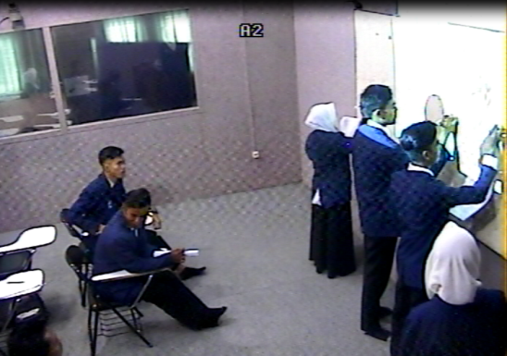

Figure 2. Subject involving students in learning
The use of the word use component in the core learning activities includes conveying material such as "Okay, before we will explain about the equation of the linear absolute value of one variable, what is absolute value? absolute value can be called the absolute value of the absolute value of the modulus and notated with symbols like this (symbol | ┤ |) which means positivated ", applying the learning strategy" Mother uses the STAD learning method. Alright, mother will make you into a group here, group 1, group 2, yes (teacher divides students into 2 groups), use learning media, carry out classroom management. "I will give Student Worksheets to each group, please discuss with friends. This is group 1 group 2 (the teacher distributes student worksheets to each group) discuss with his friends, circular also does nothing ", involve students in learning and conduct assessments in learning such as" Mother saw the questions from the quiz answers before the mother can give you an award which group is the best which group is good (the teacher corrects the quiz results of students and gives awards) the best group is group one ". In the core activities, word use is used as a keyword and initial information is given to students in accordance with the material to be taught. This is in accordance with the statement that the word use used in mathematical discourse includes specific words (certain words) (Mosvold, 2016). In addition, word use is used as material that must be explained to students (explaining activities). This is consistent with the opinion (Ngin, 2018) that word use is important in the discourse of mathematics in this activity because it helps convey meaning to students.
Visual mediators in this case are using power points and using existing worksheets (the work done in UK is worksheets) as Figure 3, blackboards and explanations are student teacher candidates giving questions. In the context of commognitive subjects using concrete media that can be seen and real. This is in accordance with the opinion of (Sfard, 2008) who revealed that this concrete mediator can be seen and seen in plain view. In addition, in his theory, Bruner also believes that conceptual understanding can be improved if students are confronted with different representations of a concept on three main types of representations: concrete, iconic, and symbolic (Cabahug, 2012).

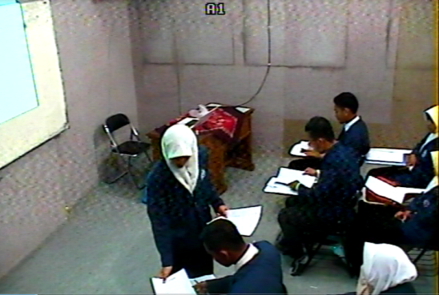

Figure 3. Subject using existing worksheets
The narrative component conducted by students is to use the concept of absolute value. This is in accordance with the opinion that the narrative is more to explain the concept of limits to students and students better understand them, including providing scaffolding in explaining the concept and the process of solving problems (Zayyadi, 2020). Routine component that is done by prospective teacher includes explaining the meaning of the limit and explaining about | x | "Yes, for example x is a real number so if the symbol is like this | x | can read the absolute value x ".This is in accordance with the opinion of (Leinhardt, 1990), instructional explanation aims to explain concepts, procedures, events, ideas and class problems to help students understand, learn and use information in flexible ways. Subject also gave several questions on the sidelines of explaining the material. It is consistent that questions can determine the extent of understanding students have (Zayyadi, dkk., 2019). In addition, subject did the explanation by giving some rituals as well as giving questions to students during the learning interaction. The activity is appropriate that routines can be categorized into exploration, deeds and rituals (Sfard, 2008). Communication frameworks related to types of routines are deeds, rituals or exploration (Tabach & Nachlieli, 2016).

  - Closing Activities
In the closing activity, students carry out several steps of learning such as summarizing learning material and reflecting on learning. The activity looks like below:
Subject: Okay, so that we do not forget the material, we can look back at what is the linear absolute value equation of one variable, maybe someone knows?
Student: Equations involving absolute value with one variable and high rank are one
Subject: Good
Student: The equation of absolute value with one variable is an equation that involves absolute value with one variable having the highest rank of one.
Subject: Good so the linear absolute value equation of one variable is the equation that involves having the highest rank is one. Well, before closing the lesson today, next week we will learn about ranks and sequences
Student: Yes Sir
Subject: Please learn about ranks and sequences
Student: Yes Sir, ready.
Subject: And maybe that's all you can say, less and more, sorry, wassalamu 'alaikum Wr. Wb.
Student: Wa'alaikumsalam Wr. Wb.

Word use in this activity gives students the ability to conclude their own conclusions from learning, ask students to learn the next material "Please learn about ranks and sequences", and say the closing sentence "assalamualaikum warahmatullahi wabarakatuh". Routine in this activity is to provide an opportunity to make their own conclusions from the learning done, motivate students to learn at home about the material to be studied next meeting and close learning.

Discussion
Based on the above research results, the commognitive component of prospective teacher students in learning mathematics used is word use, visual mediator, routine and narrative. Word use that is done by the subject is with mathematical terms, colloquial words and other mathematical terms as key words in accordance with the material being taught and word use is used as a keyword and initial information is given to students in accordance with the material to be taught. This is in accordance with the statement that the word use used in mathematical discourse includes specific words (certain words) (Mosvold, 2016). Word use is used such as limit, real number, and other equations (mathematical terms); = (equals), the symbol x (multiplication) and so on are referred to as everyday words. Furthermore, other mathematical terms refer to words such as numerator, denominator and so on. Visual mediators in learning mathematics are using power points and using existing worksheets (the work done in UK is worksheets) as Figure 3, blackboards (each group representative writes the results of their group answers on the blackboard) and explanations are student teacher candidates giving questions (Ok from your answer here, I can conclude that you already understand about the equation of the linear absolute value of a variable. Alright mom will give you a quiz (teacher gives quiz questions to students). In the context of commognitive subjects using concrete media that can be seen and real. This is in accordance with the opinion of (Sfard, 2008) who revealed that this concrete mediator can be seen and seen in plain view.
The narrative component conducted by students is to use the concept of absolute value. This is in accordance with the opinion that the narrative is more to explain the concept of limits to students and students better understand them, including providing scaffolding in explaining the concept and the process of solving problems (Zayyadi, dkk., 2020). Routine component that is done by prospective teacher includes explaining the meaning of the limit and explaining about | x | "Yes, for example x is a real number so if the symbol is like this | x | can read the absolute value x ".This is in accordance with the opinion of (Leinhardt, 1990), instructional explanation aims to explain concepts, procedures, events, ideas and class problems to help students understand, learn and use information in flexible ways.

Conclusion
Based on the results and discussion it can be concluded that this is the Teaching Skills of Prospective Mathematics Education Teachers in microteaching Subjects in a commognitive perspective capable of carrying out preliminary activities, core activities and closing activities. Prospective teacher students in this study did not implement the application of the concept of the material conveyed in their daily lives. In the commognitive perspective student teacher candidates use all the commognitive components such as word use, visual mediator, narrative and routine. The use of the word use component in learning activities includes conveying material such as "Okay, before we will explain the equation of the linear absolute value of one variable, what is absolute value? absolute value can be called the absolute value of the absolute value of the modulus and denoted by a symbol like this (symbol | ┤ |) which means it is positivated ", Visual mediator in this case is to use a power point and use the existing worksheet (the UK employed is contained in the worksheet) , the blackboard and do the explanation is the prospective teacher students give questions. The narrative component conducted by students is to use the concept of absolute value. Routine component that is done by prospective teacher includes explaining the meaning of the limit and explaining about | x | "Yes, for example x is a real number so if the symbol is like this | x | can read the absolute value x ".
Based on the results of this study, the teaching skills of prospective teacher students can be assessed with commognitive theory. Commognitive describes the skills of prospective teacher students in learning mathematics from all components of the commognitive. therefore, future research can examine pedagogical prospective teacher students in a commognitive perspective.

