Lampiran 1 Permasalahan Sharing Task Nomor 1
Monthly Doctor Death Data in indonesia
Data Update: September 30, 2020 (09.00 WIB)
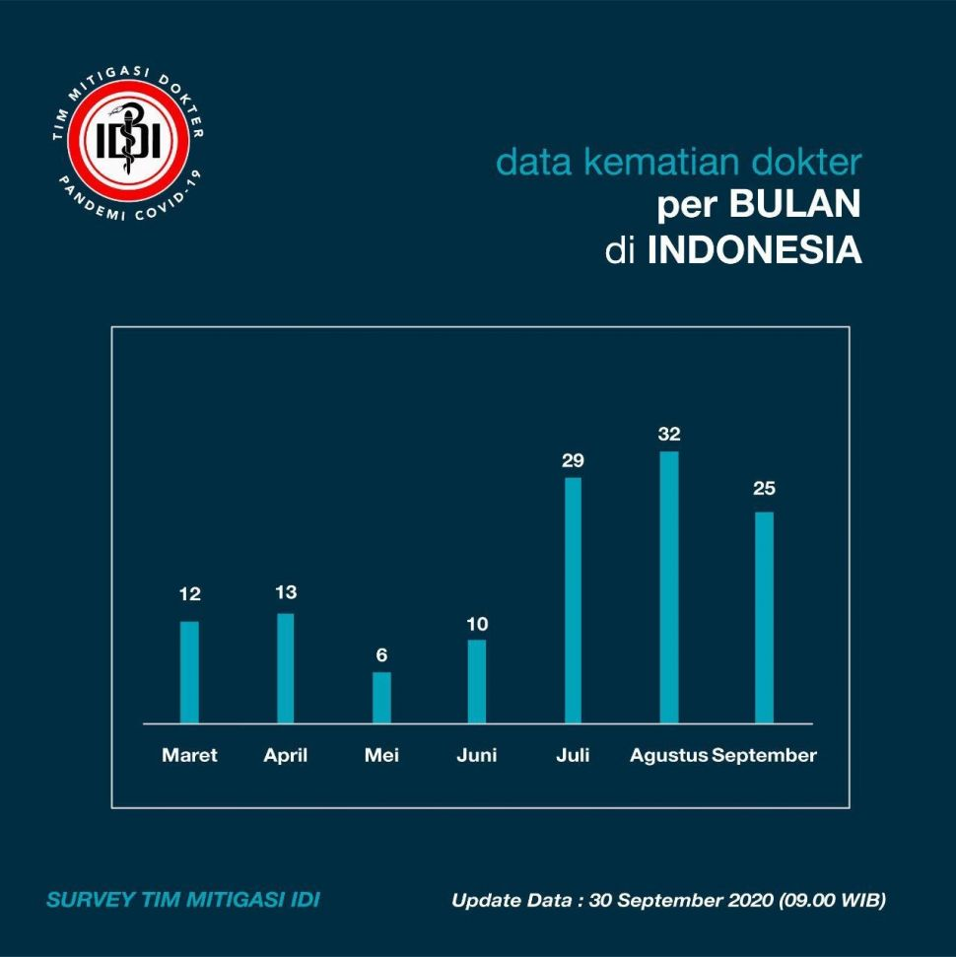
(Image Source www.suara.com)
Based on the above data, determine the number of doctors who died from March to September.

Permasalahan Sharing Task nomor 2
Distribution of the Number of Doctor Deaths in Indonesia by Monthly
Data update: Desember, 31 2020 (00.00 WIB)
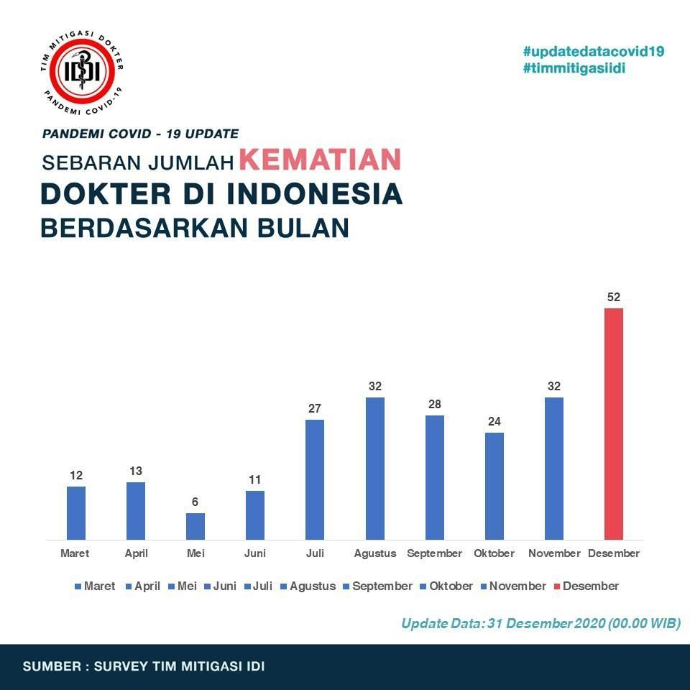
(Image Source www.suara.com)
Based on the data above, determine which month there was the largest increase in the number of doctor deaths?

Lampiran 2 Permasalahan Jumping Task
Graph of New Corona Cases per Day
As of April, 27, 2020 at 16.00 WIB

(Image Source www.news.detik.com)
Please check whether it is true that the increase in the number of deaths from April 18 to 19 is lower than the increase in the number of deaths from April 23 to 24 2020 at 16.00 WIB.

