
Dear:
Editors of Jurnal Elemen
Mathematics Education Department, Faculty of Mathematics and Sciences, Universitas Hamzanwadi
St. TGKH M. Zainuddin Abdul Madjid No. 132 Pancor-Selong, Lombok Timur, Nusa Tenggara Barat, Indonesia, Postcode: 83611
Website: http://e-journal.hamzanwadi.ac.id/index.php/jel; Email: jurnalelemen@hamzanwadi.ac.id

ETHICAL STATEMENT LETTER

First author’s name | : Siti Maryam Rohimah
First author’s email | : sitimaryamrohimah@upi.edu
First author affiliation | : Pasundan University; Indonesia University of Education
Second author’s name | : Darhim
Second author’s email | : darhim@upi.edu
Second author affiliation | : Indonesia University of Education
Third author’s name | : Dadang Juandi
Third author’s email | : dadang.juandi@upi.edu
Third author affiliation | : Indonesia University of Education

Hereby, we are authors consciously assure that for the manuscript “A Local Instruction Theory (LIT) for Teaching Linear Equation in One Variable Through STEM Instruction using a Dynamo-Powered Toy Car” the following is fulfilled:
- This material is the authors' own original work, free from fabrication, falsification, plagiarism, duplication, and copyright infringement of data/content.
- The paper is not currently being considered for publication elsewhere and has not been previously published elsewhere.
- The paper will not be withdrawn and sent to other journals during the assessment process by the journal
- The paper does not contain any unlawful, defamatory, or other statements and does not contain material that violates any other person or entity's rights or property rights.
- The paper reflects the authors' own research and analysis wholly and truthfully.
- The paper properly credits the meaningful contributions of co-authors and co-researchers.
- The results are appropriately placed in the context of prior and existing research.
- All sources used are correctly disclosed (correct citation). Copying of text must be indicated as such by using quotation marks and giving proper reference.
- All authors have been personally and actively involved in substantial work leading to the paper and will take public responsibility for its content.

City/Country, date/month/year
Corresponding author’s name & signature  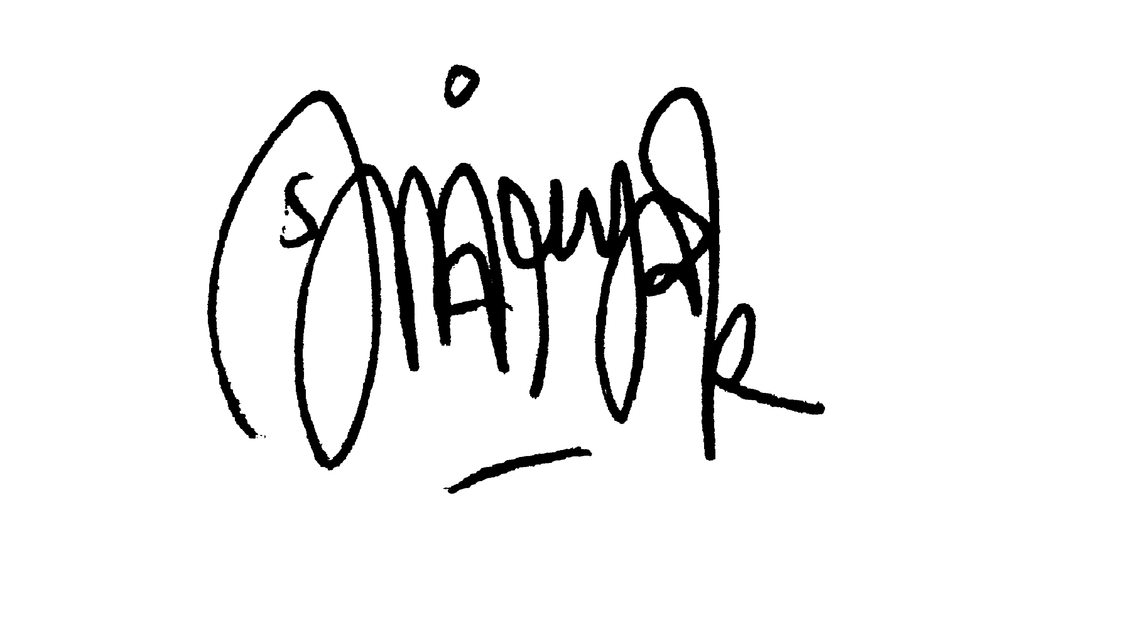  Siti Maryam Rohimah | : Bandung, 10 Desember 2021

