
Spatial Thinking Ability: Case Study in Solving the Minimum Competency Assessment (AKM) on Geometry Materials
© The Author(s) 2022
Abstract
Reflecting on PISA and TIMSS, which are international literacy and numeracy assessments, the Indonesian government will begin implementing the Minimum Competency Assessment (AKM) for elementary, junior high and high school students. Two basic competencies that will be assessed using this AKM are literacy and numeracy. In assessing numeracy skills, there will be math problems, one of which is geometry. When solving geometric problems, students need spatial thinking ability. Spatial thinking ability is a set of skills that people use every day, including recognizing shapes and sizes; identifying and remembering object locations; reconstructing patterns; reading maps, diagrams, and directions; rotating and manipulating shapes and objects. The spatial thinking ability, especially regarding its appearance in AKM problems, is essential for students. This study aims to describe students' spatial ability in solving AKM geometry questions. This research is descriptive with a qualitative approach. The research subjects were junior high school students. The instrument used for data collection is a test sheet. The research was conducted in three stages: preparation, implementation, and data analysis. The results showed that three aspects of spatial ability, namely spatial visualization, spatial orientation, and spatial relations, had not yet fully emerged from junior high school students. One student has fulfilled the aspects of visualization and visual orientation but has not satisfactorily met the aspects of spatial relations.
Keywords: Spatial Thinking Ability, AKM, Geometry
Received: Date Month Year | Revised: Date Month Year
Accepted: Date Month Year | Published: Date Month Year

Introduction
To produce a generation with a higher level of thinking, the Indonesian Ministry of Education and Culture (Kemendikbud) made an innovation by implementing the Minimum Competency Assessment (AKM). Reflecting on PISA and TIMSS, which are assessments in international literacy and numeracy, the Indonesian government will start implementing AKM for elementary, middle and high school students. AKM is one of the national assessments to photograph the process and quality of student learning outcomes in Indonesia. AKM focuses on measuring students' literacy and numeracy competencies (Mendikbud, 2020). Although it has not yet been implemented, the Ministry of Education and Culture has conducted socialization and training for schools regarding the technicalities and variety of AKM questions. However, many education practitioners (teachers and students) do not understand this AKM. It can be seen from the research (Rokhim et al., 2021), which is based on a survey of 116 students in East Java regarding the understanding of AKM. This study stated that 53.2% of students did not understand and recognize the minimum competency assessment (AKM).
Two essential competencies that will be assessed using this AKM are literacy and numeracy. Literacy is the ability to understand, use, evaluate and reflect on various texts. At the same time, numeracy is the ability to use mathematical concepts, facts, and procedures to solve real-life problems relevant to students' lives (Mendikbud, 2020). Students' daily lives are closely related to mathematical material, especially geometry (Baeti & Murtalib, 2019; Hidayati, 2019; Jamil & Dintarini, 2021).
Geometry is an important material in mathematics. Geometry is considered a difficult material compared to other materials in mathematics (Nur’aini et al., 2017; T.R., 2017; Ubi & Odiong, 2018). By studying geometry, students will also practice spatial abilities. Spatial ability is a set of skills that people use every day, including recognizing shapes and sizes; identifying and remembering the location of objects; reconstructing patterns; reading maps, diagrams, and directions; rotating and manipulating shapes and objects (Pruden et al., 2020).
Spatial ability has been a topic of research for centuries. Previous researchers have made various attempts to improve spatial abilities. Moss et al. (2015) adapted lesson study in Japan to improve students' spatial reasoning ability. The result found that the model effectively supported teachers' spatial knowledge and reasoning and reduced their awareness of geometry and spatial reasoning.
Safhalter et al. (2016) conducted 3D Modeling training using SketchUp software, viewed by gender and age. The research found that the 3D model effectively improves students' spatial ability, especially in object manipulation indicators.
Other research reveals that students' spatial abilities affect students' performance in solving math problems (Lowrie et al., 2016; Novak & Tassell, 2017). So, spatial thinking ability is crucial for student life, especially regarding its appearance in AKM problems. AKM problems contain geometry and require spatial thinking skills. From the explanation above, the researcher takes the formulation of the research problem, how is the students' spatial thinking ability in solving geometry AKM problems?

Methods
This research is descriptive with a qualitative approach. The purpose of the study was to describe students' spatial abilities in solving AKM-based questions on geometry material. Research with qualitative methods was chosen to explore the results of student work in the form of steps or student processes in solving AKM-based geometry problems. The research subjects were seventh-grade students of SMP Muhammadiyah 4 Malang.
The instrument used for data collection is a test sheet. The test sheet was developed based on AKM and based on indicators of spatial ability with geometry material. Therefore, the data collection technique is the provision of AKM-based geometry tests. The data analysis technique used data triangulation, namely 1) data reduction, 2) data presentation and 3) drawing conclusions and verification. Data reduction was carried out to summarize and select data that matched the research focus, namely the students' spatial abilities obtained from the students' work on the AKM-based geometry test. Data presentation is done as a step after data reduction. The presentation of the data simplifies the process of analyzing the data, where the data are grouped based on indicators of spatial ability. The last is making data conclusions and verification.
The preparation stage is carried out by conducting a literature study, namely looking for references from journal articles, books, and interviews with the school regarding the Minimum Competency Assessment (AKM) and students' spatial abilities in geometry material. In addition, at this stage, the development of research instruments in the form of test questions is carried out. The research instrument is further validated to ensure its feasibility. The implementation stage is carried out together with the chairman and all research members by providing test questions developed based on AKM and indicators of spatial ability. After the data is obtained, proceed with data reduction, data analysis, and finally, conclude. The last stage is reporting.

Results and Discussion
A test was given to 30 students of SMP Muhammadiyah Malang. The test given is an AKM problem for geometric materials that require students' numeracy literacy and spatial thinking skills. The test questions are arranged through team discussions to get questions that can be used to see students' numeracy literacy skills and bring up aspects of spatial thinking. The following are AKM test questions given to students.
Siti wants to renovate her bathroom, which is 2 meters long and 2 meters wide. Mayang bathroom floor will be fitted with square tiles with a pattern like a picture below.
It turned out that the surface of the bathroom floor only needed four tiles.
What is the size of each tile?
Draw the arrangement of tiles that might be installed on the floor.
Again look at the arrangement of the tiles. In the middle, there is a rectangle with ​​0.08 m2. Determine the area of ​​the hexagon contained in one tile motif!

Five students were selected from 30 students who took the test to describe their spatial thinking skills based on aspects of students' spatial thinking skills, namely visualization, orientation and spatial relations. The description of students' spatial thinking skills will be explained by researchers based on these three aspects.

Spatial Visual Aspect
The aspect of spatial visualization is characterized by students being able to manipulate, rotate or flip a geometric object. The students' ability to manipulate geometric objects can be seen in the students' answers to question b. In question b, students are asked to draw a possible arrangement of tiles for the bathroom. The following are some of the results of student work.
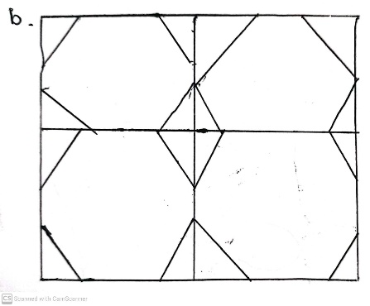
Figure 1. Results of answers to question b students' AR
In figure 1, AR students correctly described the arrangement of tiles that might be installed in a bathroom. AR's ability to manipulate geometric objects in his mind is closely related to his answer to question a. In answering the question a (what is the size of each tile), AR first writes down information that may be useful in solving the given problem. Then write down the solution plan.
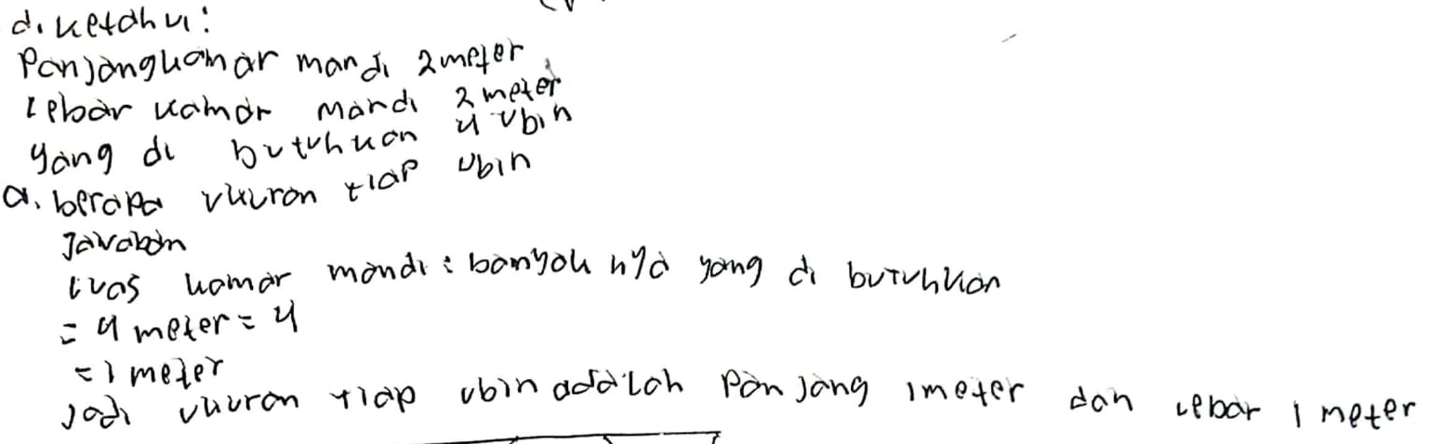
Figure 2. Results of answers to questions a student AR
AR solves the tile size problem by dividing the bathroom area by the number of tiles needed. To solve this problem, AR starts by imagining a possible arrangement of tiles according to the size of the bathroom. This means that AR manipulates and rotates geometric objects (tiles). Manipulation occurs when AR imagines four tiles arranged like picture a, then adjust the image to the conditions given in the problem. AR might also imagine other possible forms of placing tiles in the bathroom. However, he did not get another form that satisfied the conditions given in the problem.
In contrast to AR, student B described the arrangement of bathroom tiles with only two tiles, as shown in Figure 2.
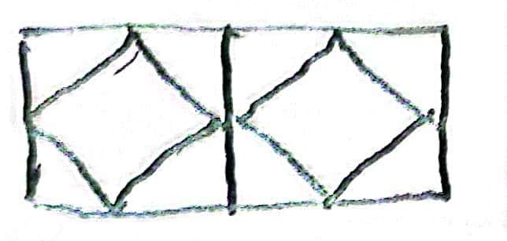
Figure 3. The results of the answers to question b student B
Students describe the arrangement of tiles like the picture above because they do not understand the problem. It was indicated by the following student B's answers to problem a.
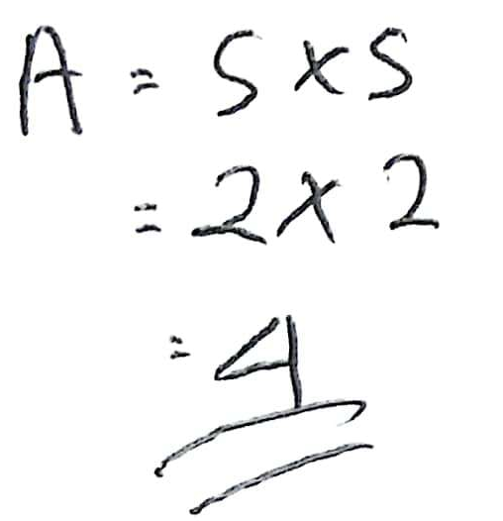
Figure 4. Results of answers to question a student B
In answering problem a, student B writes down. This is the formula for the area of ​​a square. Actually, B has started the initial step in solving problem a. However, B did not continue it by adding further information needed, namely information on the number of tiles that can be installed in the bathroom. Therefore, the spatial visualization aspect has not been seen in work B. Most subjects describe the arrangement of tiles as student B, indicating that students still lack mastery of the spatial visualization aspect. This is supported by research $A=s×s=2×2=4$Rahman et al. (2017), which states that the visualization error of the diagnostic test performed is greater than the other errors. This shows that students still have difficulties visualizing geometric objects in solving AKM problems. This is also found in Tias & Wutsqa (2015), which state that students have difficulty understanding visual-spatial 3.54%, difficulty applying visual-spatial 3.10%, and difficulty analyzing visual-spatial 2.65%.

Aspects of Spatial Orientation
The second aspect of spatial ability is spatial orientation. The indicator of the aspect of spatial orientation is that students can arrange elements into a geometric pattern. Based on the second aspect of this spatial ability, it is hoped that students can arrange the tiles given in the problem to be like the following picture:

Figure 5. The left is a picture of AR work, and the right is a picture of SW work.
Based on the data obtained from the students' work, there were AR and SW students who managed to arrange the tiles correctly. Even though the images were not precise, the students managed to arrange them into a geometric pattern. Below is an image produced by AR and SW students.
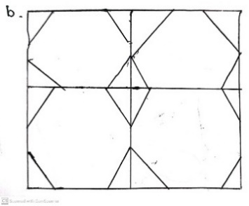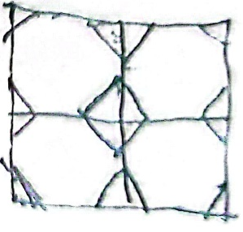
Figure 6. The left is a picture of AR work, and the right is a picture of SW work.
Some students drew the wrong arrangement of tiles to be installed on the floor as requested by the question. Student B only arranged two tiles in the picture, while in the question, it was clearly written that the bathroom floor needed four tiles. In addition, student B was also seen drawing tiles with different motifs; the blue motif in the question should be a hexagon, but what student B drew was a quadrilateral. The picture of the arrangement of tiles produced by student B can be seen in Figure 3.
The arrangement of tiles made by other students is mostly the same as the arrangement made by student B. This shows that students have not been able to distinguish between rectangular and hexagonal shapes in the tile square. In addition, students are also less careful in seeing flat shapes that build tile motifs and are less careful in reading questions related to the number of tiles needed to be arranged on the bathroom floor.
In addition to the arrangement like picture 3, student Y draws the arrangement of tiles incorrectly. The following is a picture made by student Y.
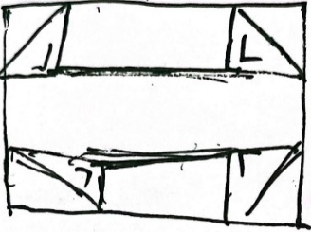
Figure 7. Arrangement of tiles made by student Y.
Student Y is seen drawing one tile motif by adding two horizontal lines so that four isosceles and triangles are formed on the tile. From Figure 3, it can be seen that student Y cannot make the arrangement of tiles correctly and does not understand the meaning of the question. Student Y was fooled by the next question that asked for the area of ​​the hexagon, so he tried to divide the picture to get the size of the hexagon from one tile motif.
Based on the results of students' work on the aspect of spatial orientation in solving geometric problems, class VII students of SMP Muhammadiyah 4 Malang do not master this aspect. Spatial ability in arranging elements into a geometric pattern is still minimal. One of the studies on the ability of junior high school students conducted in Mojokerto showed the results that only 16% of students were at a high level of spatial ability, 69% of a low level of spatial ability, and 15% were at a moderate level of ability (Putri & Imanah, 2018). Study Putri & Imanah, (2018) revealing spatial ability, which is a cognitive activity that changes the point of view when looking at a visual object owned by junior high school students, is still at a moderate level. Students' ability to manipulate, imagine, and arrange elements to form geometric patterns has not shown promising results. The lack of students' spatial ability impacts understanding of geometric concepts, and this is because spatial ability is correlated with understanding geometric concepts (Battista et al., 2018; Hasanah et al., 2018; Hwang et al., 2019).

Aspects of Spatial Relations
Aspects of spatial relations are characterized by students being able to understand, correlate, and imagine verbal descriptions into a form of the geometric object. The problem given by the researcher is in the form of story questions, where students are required to imagine and manipulate geometric shapes according to the sentence by sentence displayed in the problem. Of the 30 students who took the AKM test, only two students, namely AR and SW, understood the given problem and changed it in the appropriate arrangement of geometric objects. Although in solving problem c, AR and SW have not been able to solve it correctly. The following is the answer to AR students' question c.
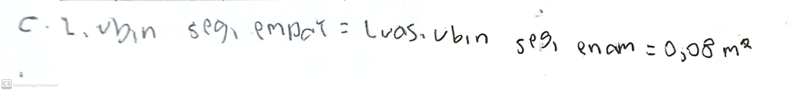
Figure 8. AR's answers to question c
In answering question c, it is seen that AR writes that the area of ​​the rectangular tile formed is the same as the area of ​​the hexagon tile. Not much can be extracted from this AR article. Apart from that, AR still relies on its vision and intuition for geometric objects. In the end, AR falls into the belief that the area of ​​a rectangular tile is equal to the area of ​​a hexagon tile. So in AR's work, the spatial relation aspect has started to emerge, as can be seen from how AR solves problems a and b but fails at c because of its belief. Therefore, teacher assistance is needed so that AR can better master aspects of spatial relations. In addition to AR, other students briefly wrote down their answers, such as 0.04 and 0.16. Other students' answers have not shown the emergence of aspects of spatial relations, and this is supported by their answers to questions a and b.
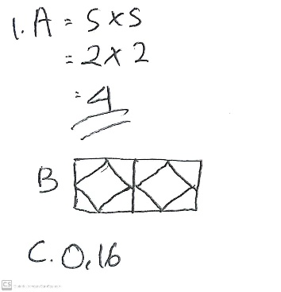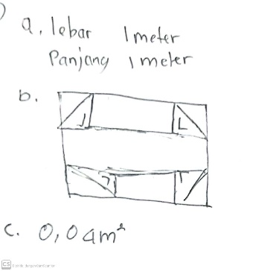
Figure 9. Answers of student B and student Y
In terms of spatial relations, SMP 4 Muhammadiyah students need teacher assistance, either in the form of scaffolding Dintarini & Zukhrufurrohmah (2021) or specific learning strategies (Fajri et al., 2017; Jamil & Dintarini, 2021).

Conclusion
Based on the research data, it was found that the spatial ability of the students of SMP Muhammadiyah 4 Malang through the provision of AKM Geometry questions did not meet the three aspects of spatial ability. The spatial abilities of AR students and B students described in the results and discussion sections have met the visualization and visual orientation aspects but have not satisfactorily met the spatial relation aspects. Meanwhile, student Y's answer represents most of the other students' answers, where the three aspects of visual ability have not been seen in their answers.

Acknowledgement
We want to express our gratitude to the Faculty of Teacher Training and Education, the University of Muhammadiyah Malang, which has provided support in materials and facilities to carry out this research well.

Conflicts of Interest

The authors declare that there is no conflict of interest regarding the publication of this manuscript. In addition, the ethical issues, including plagiarism, misconduct, data fabrication and falsification, double publication and submission, and redundancies, have been completed by the authors.

References
Baeti, N., & Murtalib, M. (2019). Analisis Keterampilan Geometri Siswa Dalam Memecahkan Masalah Geometri Berdasarkan Tingkat Berpikir Van Hiele Di MTs Muhammadiyah 1 Malang. SUPERMAT (JURNAL PENDIDIKAN MATEMATIKA), 2(2), 39–50. https://doi.org/10.33627/sm.v2i2.96
Battista, M. T., Frazee, L. M., & Winer, M. L. (2018). Analyzing the Relation Between Spatial and Geometric Reasoning for Elementary and Middle School Students. https://doi.org/10.1007/978-3-319-98767-5_10
Dintarini, M., & Zukhrufurrohmah. (2021). ANALISIS PEMBERIAN SCAFFOLDING MELALUI ONLINE FORM UNTUK MENGATASI KESULITAN BERPIKIR SPASIAL. ẟELT∆ Jurnal Ilmiah Pendidikan Matematika, 9(2), 221–232.
Fajri, H. N., Johar, R., & Ikhsan, M. (2017). Peningkatan Kemampuan Spasial dan Self-Efficacy Siswa Melalui Model Discovery Learning Berbasis Multimedia. Beta Jurnal Tadris Matematika, 9(2), 180. https://doi.org/10.20414/betajtm.v9i2.14
Hasanah, F., Rahayu, W., & Fahrurrozi. (2018). Korelasi Belief Matematik Dan Kemampuan Spasial dengan Pemahaman Konsep Geometri. Jurnal Ilmiah Pendidikan Guru Sekolah Dasar, 2(2).
Hidayati, D. N. (2019). Analisis Kesalahan Penyelesaian Soal Cerita Matematika Bertipe HOTS Berdasarkan Teori Newman Pada Siswa Kelas V SD. eprints.umm.ac.id.
Hwang, W. Y., Purba, S. W. D., Liu, Y. F., Zhang, Y. Y., & Chen, N. S. (2019). An Investigation of the Effects of Measuring Authentic Contexts on Geometry Learning Achievement. IEEE Transactions on Learning Technologies, 12(3). https://doi.org/10.1109/TLT.2018.2853750
Jamil, A. F., & Dintarini, M. (2021). Students’ Activity in Online Learning Application Using LAPS-Heuristic Model in Geometry Material. Mathematics Education Journals, 5(1), 15–28.
Lowrie, T., Logan, T., & Ramful, A. (2016). Spatial Reasoning Influences Students ’ Performance on Mathematics Tasks. Mathematics Education Research Group of Australasia, 407–414.
Mendikbud. (2020). AKM dan Implikasinya pada Pembelajaran. In Pusat Asesmen Dan Pembelajaran Badan Penelitian Dan Pengembangan Dan Perbukuan Kementerian Pendidikan Dan Kebudayaan.
Moss, J., Hawes, Z., & Naqvi, S. (2015). Adapting Japanese Lesson Study to enhance the teaching and learning of geometry and spatial reasoning in early years classrooms : a case study. https://doi.org/10.1007/s11858-015-0679-2
Novak, E., & Tassell, J. L. (2017). Studying preservice teacher math anxiety and mathematics performance in geometry, word, and non-word problem solving. Learning and Individual Differences, 54. https://doi.org/10.1016/j.lindif.2017.01.005
Nur’aini, I. L., Harahap, E., Badruzzaman, F. H., & Darmawan, D. (2017). Pembelajaran Matematika Geometri Secara Realistis Dengan GeoGebra. Matematika, 16(2), 1–6. https://doi.org/10.29313/jmtm.v16i2.3900
Pruden, S. M., Nazareth, A., Odean, R., Abad, C., Bravo, E., & Garcia, N. (2020). Movement, Space, and the Development of Spatial Thinking. The Encyclopedia of Child and Adolescent Development, 1–15. https://doi.org/10.1002/9781119171492.wecad029
Putri, R. O. E., & Imanah, U. N. (2018). Studi tentang Kemampuan Spasial Siswa Sekolah Menengah Pertama (SMP) di Mojokerto. MAJAMATH: Jurnal Matematika Dan Pendidikan Matematika, 1(2). https://doi.org/10.36815/majamath.v1i2.235
Rahman, A. D., Susongko, P., & Sholikhakh, R. A. (2017). PENGEMBANGAN INSTRUMEN TES DIAGNOSTIK PADA MATERI GARIS DAN SUDUT DENGAN PEMODELAN TEORI RESPON BUTIR ( STUDI PENGEMBANGAN PEMBELAJARAN MATEMATIKA DI SMP NEGERI 7 PEMALANG ). Jurnal Pendidikan MIPA Pancasakti, 1(1), 1–10.
Rokhim, D. A., Rahayu, B. N., Alfiah, L. N., Peni, R., Wahyudi, B., Wahyudi, A., Widarti, H. R., & Malang, U. N. (2021). Analisis Kesiapan Peserta Didik Dan Guru Pada Asesmen Nasional ( Asesmen Kompetensi Minimum , Survey Karakter , Dan Survey Lingkungan Belajar ). Jurnal Administrasi Dan Manajemen Pendidikan, 4, 61–71.
Šafhalter, A., Vukman, K. B., & Glodez, S. (2016). The Effect of 3D-Modeling Training on Students’ Spatial Reasoning Relative to Gender and Grade. Journal of Educational Computing Research, 54(3), 395–406. https://doi.org/10.1177/0735633115620430
T.R., F. (2017). Geometry Concepts in Mathematics Perceived Difficult To Learn By Senior Secondary School Students in Ekiti State, Nigeria. IOSR Journal of Research & Method in Education (IOSRJRME), 07(01). https://doi.org/10.9790/7388-0701018390
Tias, A. A. W., & Wutsqa, D. U. (2015). Analisis Kesulitan Siswa Sma Dalam Pemecahan Masalah Matematika Kelas Xii Ipa Di Kota Yogyakarta. Jurnal Riset Pendidikan Matematika, 2(1), 28. https://doi.org/10.21831/jrpm.v2i1.7148
Ubi, E. E., & Odiong, A. U. (2018). Geometry Viewed as a Difficult Mathematics. International Journal of Innovative Science and Research Technology, 3(11).

