
Dear:
Editors of Jurnal Elemen
Mathematics Education Department, Faculty of Mathematics and Sciences, Universitas Hamzanwadi
St. TGKH M. Zainuddin Abdul Madjid No. 132 Pancor-Selong, Lombok Timur, Nusa Tenggara Barat, Indonesia, Postcode: 83611
Website: http://e-journal.hamzanwadi.ac.id/index.php/jel; Email: jurnalelemen@hamzanwadi.ac.id

ETHICAL STATEMENT LETTER

First author’s name | : Elisabet Ayu Ani Senjaya
First author’s email | : elisabetani.2020@student.uny.ac.id
First author affiliation | : Department of Educational Technology, Universitas Negeri Yogyakarta
Second author’s name | : Ali Muhtadi
Second author’s email | : alimuhtadi@uny.ac.id
Second author affiliation | : Department of Educational Technology, Universitas Negeri Yogyakarta
Third author’s name | : Julham Hukom
Third author’s email | : julhamhukom.2020@student.uny.ac.id
Third author affiliation | : Department of Educational Technology, Universitas Negeri Yogyakarta
Fourth author's name | : Abdul Manaf
Fourth author's email | : abdulmanaf.2017@student.uny.ac.id
Fourth author's affiliation | : Department of Educational Research and Evaluation, Universitas Negeri Yogyakarta

Hereby, we are authors consciously assure that for the manuscript “Effect of Blended Learning Model on Mathematical Skills: Meta-Analysis Study” the following is fulfilled:
- This material is the authors' own original work, free from fabrication, falsification, plagiarism, duplication, and copyright infringement of data/content.
- The paper is not currently being considered for publication elsewhere and has not been previously published elsewhere.
- The paper will not be withdrawn and sent to other journals during the assessment process by the journal
- The paper does not contain any unlawful, defamatory, or other statements and does not contain material that violates any other person or entity's rights or property rights.
- The paper reflects the authors' own research and analysis wholly and truthfully.
- The paper properly credits the meaningful contributions of co-authors and co-researchers.
- The results are appropriately placed in the context of prior and existing research.
- All sources used are correctly disclosed (correct citation). Copying of text must be indicated as such by using quotation marks and giving proper reference.
- All authors have been personally and actively involved in substantial work leading to the paper and will take public responsibility for its content.

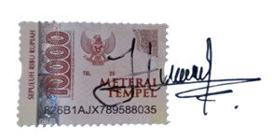
Yogyakarta/Indonesia, 13/July/2022
Corresponding author’s name & signature | :  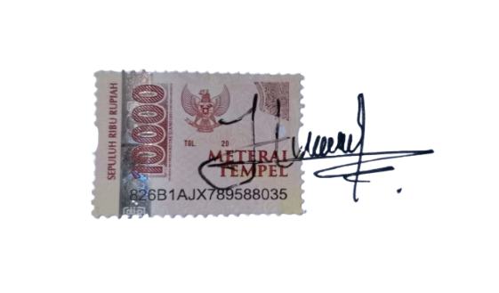  Julham Hukom

