CHAPTER IV
RESEARCH FINDINGS AND DISCUSSION
This chapter describes the Teaching English for Young Learners Using Cambridge Curriculum at Al Azhar School Solo Baru: Case Study. This chapter presents the answers of problem statements stated in the first chapter. The research problems raised are: How are the implementation of teaching English to young learner using Cambridge curriculum?; What are the problems of teaching English to young learner using Cambridge curriculum?; What are the solutions of teaching English to young learner using Cambridge curriculum?
- Research Findings
The research presents the description of some aspects within problem statements that are the implementation, problem faced by teachers and the solution taken by the teachers.
- The implementation of teaching English to young learners using Cambridge curriculum.
In order to answer the first research problem, the researcher carried out two times of observation for each class, guided the interview, and collecting the supported documents. The researcher conducted the structured interview with specific question using Bahasa Indonesia to get data more valid.
- Teacher A
Observation was carried out on Wednesday, 13rd November 2022 and January 4th 2023 at 1st grade of Bilingual class (1 Utsman) in Mr.Fa class. The material taught by teacher at the time was Unit 4 Lunch Menu and The Part of The House.
- Method
Based on the data observation, the teacher used Audio-Visual and Translation Method in his class. Audio visual method is learning supported by multimedia as the combination of various digital media types, such as text, image, sound, and video, into an integrated multi-sensory interactive application or presentation to convey a message or information to audiences. Moreover, teacher used interactional devices in audio visual method such as film projectors, radio, television, charts, posters, models, field trip.
The 1st grade consists of 24 students, 13 boys and 11 girls. Teacher used E-book of Super Minds launched by Cambridge Assessment. The students used two books, student’s book for materials and Activity’s book for exercises and assessment. Teacher did not use additional media like power point or showing another video. Super Minds E-Book was good, practice and easy to understood by students and completed by other features. The using of E-book that supported by English skill advance’s features indicated that audio visual method is needed to help students to understand and improve their knowledge, moreover the students were 6-7 years old, they need visual and concrete objects in learning something, especially in mastering vocabularies. Teacher rare used native language or translating the words. It conducted in order students can habituate listen and practice from simple words that they got from daily conversation.
Listening section was conducted in 1st grade of Utsman. Audio on E-book was played for students, they focus to listen the sound and find the appropriate words. Teacher helped them by saying repeatedly the words like in audio. The words lists have been prepared by Cambridge for 1st grade students to find the words easily. The words have similar sound, it was tricky and need to be focus and concentrate with the audio’s sound. Teacher went around while checking students’ works.
In the class section, teacher delivered the materials that they would learn in that time. For introducing the materials, teacher asked them about the menu of lunch that they usually eat when break-time. Students automatically gave enthusiast responses and tried to answer the kinds of lunch menu. Teacher started to show off the materials by projector then explain the kinds of lunch menu. Teacher also gave understanding how to say having something.
In listening section, teacher played the audio that filled many words. Students listened carefully and recalled those words. After they listen the audio, they were asked to answer the quiz related to the vocabularies. They should match the short conversation with the correct pictures. Sometimes, the models of listening questions such as completing short conversations with vocabulary that was appropriate to the context being discussed.

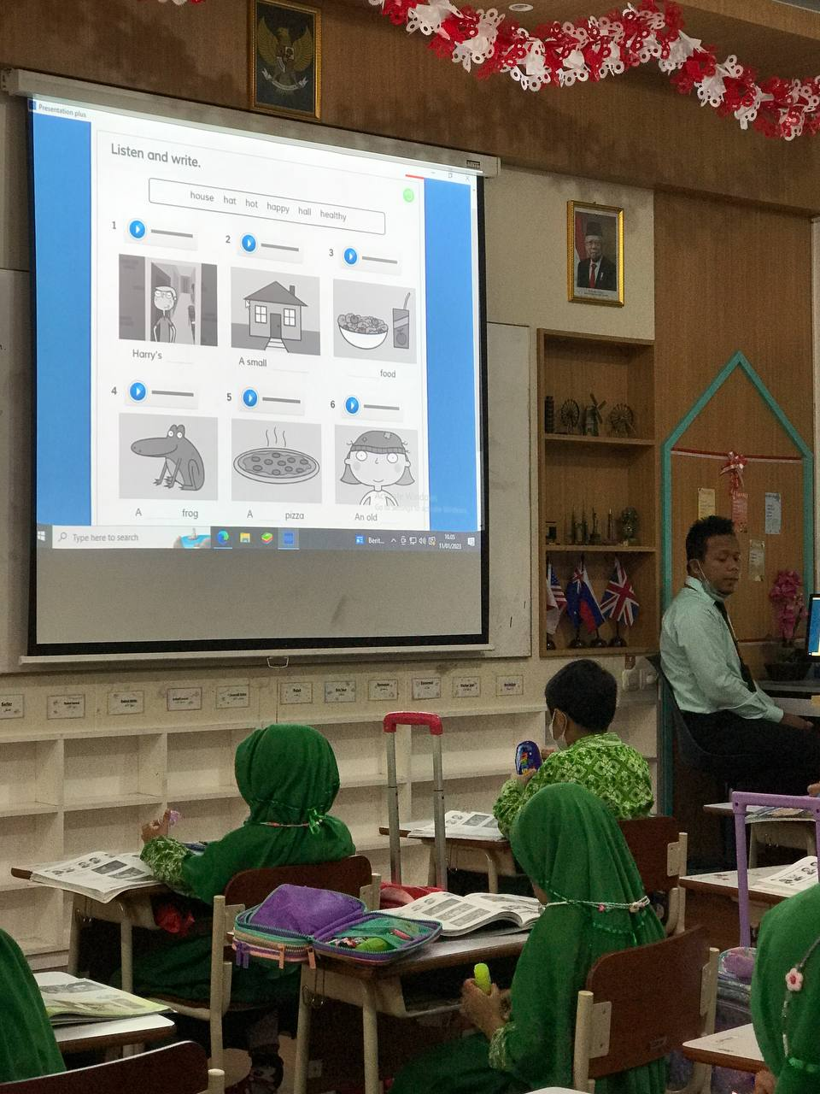
Figure 1. using audio-visual method in listening
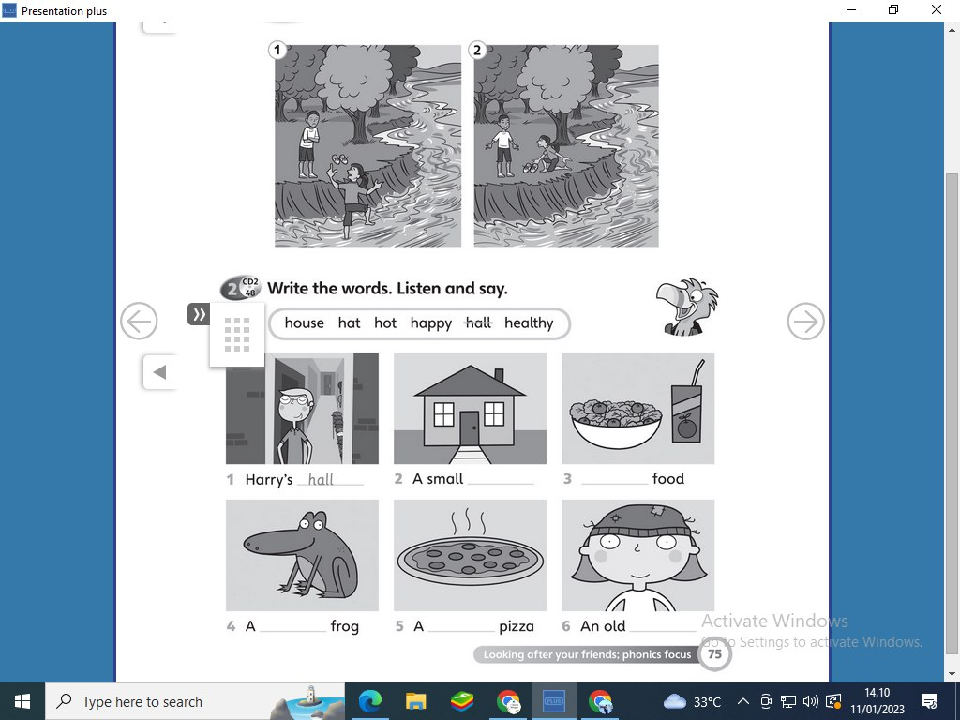
Figure 2. The Material of E-book for 1st grade students
The teacher cleared by his statements on the interview that he used audio visual when he taught English.
“Untuk kelas 1 bilingual, saya mencoba menggunakan audio visual method dan direct method karena anak-anak bilingual harus dibiasakan menggunakan bahasa inggris. Audio visual method dipilih karena untuk memudahkan anak-anak memahami materi yang harus diperjelas dengan menggunakan tayangan gambar ataupun video. …..”
Based on the statements above, Mr. Fa used audio-visual and translation method in teaching English to the young learners in that session. This method helped the learners accept the materials well and they could follow the instruction to do the worksheet after the materials delivered.

Cambridge curriculum serves many ways in teaching English that support for young learners. For instance, learning English for grade 1 more emphasized for learning vocabulary which was taught in many varieties of interesting and easy ways. It was complemented by pictures, so that young learners can memorize vocabularies strongly and can use them in everyday conversation. In visualizing images and audio, Cambridge Curriculum had designed e-books, student's books and activity books using simple word choices, supported pictures for learning, materials to teach material to young learners. so that young learners are able to adapt in learning. Therefore, audio-visual is the right method used by Mr Fa to teach English to young learners in grade 1.
Meanwhile, translation method is the teaching method emphasizes using target language full without any translation. The translation was needed as the bridge to help young learners understand the meaning and make connections between the two languages. However, it was essential to gradually reduce the reliance on translation as the students' English proficiency improves. Students were encouraged to express their thoughts and ideas in English, and the teacher provided assistance by translating their responses or clarifying meanings when necessary.
In interview section, teacher A stated that he used translation method and the reason why he used that method in teaching English for young learners. Furthermore, the researcher took another evidence in teaching process. Teacher translated his explanation after he delivered the instruction to students in English.
“Beberapa kali saya bantu dengan metode terjemah untuk menyampaikan suatu informasi yang mungkin anak-anak belum mengerti tapi jarang, biasanya anak-anak sudah paham makna suatu kata melalui gambar yang saya tayangkan. Ketika kita menggunakan bahasa inggris di kelas dengan intonasi yang jelas dibantu dengan gesture yang tepat, anak-anak akan mengerti dan terbiasa dengan bahasa inggris. Hanya saja tidak semuanya mampu membalas percakapan dengan menggunakan bahasa inggris karna mereka baru 1 semester di kelas 1. Yang terpenting adalah guru dulu, nanti murid akan mencontoh yang diucapkan gurunya”
“C-E-L-L-A-R. oke, next please open your book, page 50. After this, if you got finish and I’ll give you the instruction to do this work, then you can bring it to mr, mr will check and give you score. Setelah kalian selesai dan mr fa memberikan instruksi kepada kalian, baru boleh dibawa ke mr dan I’ll give you the score.”
Teacher A used translation to help the students get the points of the materials. Delivering English fully was not recommended for the non-native English learners. The students would get the problem in understanding the materials and misinterpreting the concepts. Therefore, teacher A translated his explanations from English to Indonesian in delivering materials.
There were no differences between first and second observation. Both observations, teacher used audio visual and direct method.
- Classroom Procedure
Based on the direct observation in the class, learning activities was divided into 3 parts, namely opening, main activity, and closing. In each hour of learning was held 30 minutes. For English class, there are 3 hours of learning in a week. the brief pattern of the classroom procedure as follows:
- Opening
Based on both observations, at the beginning Mr Fa opened the class by salam, continued by greeting the students and check the attendances. Before starting the lesson, young learners were invited to pray. Mr fa invited students to pray in a different style from other teachers. He used song involving fingers to act out instructions from Mr. Fa.
“3, 2,1 one finger on the right, 1 finger on the left, join to be one, it is like a bridge . 2 finger on the right, 2 finger on the left, join to be one it is like photo. 3 finger on the right, 3 fingers on the left join to be one. It is like a rabbit. 4 fingers on the right, 4 fingers on the left join to be one. It is like a tower. 5 finger on the right, 5 finger on the left join to be one we ready to pray. Audzubiillahi minassyaiton nirojim, bismillahirohmanirohim. Robbi zidni ilma, warzuqni fahma. Aamiin”
Mr Fa also gave his statements on interview section. He used song before praying because he taught 1st grade students. He explained the other steps in opening.
“Cara membuka pelajaran yang pasti dengan salam, setelah itu berdoa dengan cara mengajak anak berdoa dengan menggunakan nyanyian untuk persiapan mengangkat tangan. Karena kelas 1 adalah usia termuda di level primary school dan masa peralihan dari playgroup ke primary school jadi guru kebanyakan mengajak anak-anak untuk melakukan suatu kegiatan dengan bernyanyi, salah satunya beroda. Setelah berdoa, saya selalu menanyakan keadaan siswa (greeting) ini wajib ada untuk mengawali pembelajaran, mengecek absensi siswa yang hadir, dan mereview materi yang sudah diajarkan di pertemuan yang lalu biasanya saya menanyakan tentaang vocabularies agar anak-anak ingat dan dapat menerapkan di dalam aktivitasnya.”
Teacher used different way for opening the class. Sing a song was being alternative way to make young students enjoy in English class. It was conducted before they prayed. The students of 1st grade bilingual could not reply to speak English yet, they were still trying to construct and rearrange the sentences to give responses. But all of them can understand what teacher said although teacher speaks English fully.
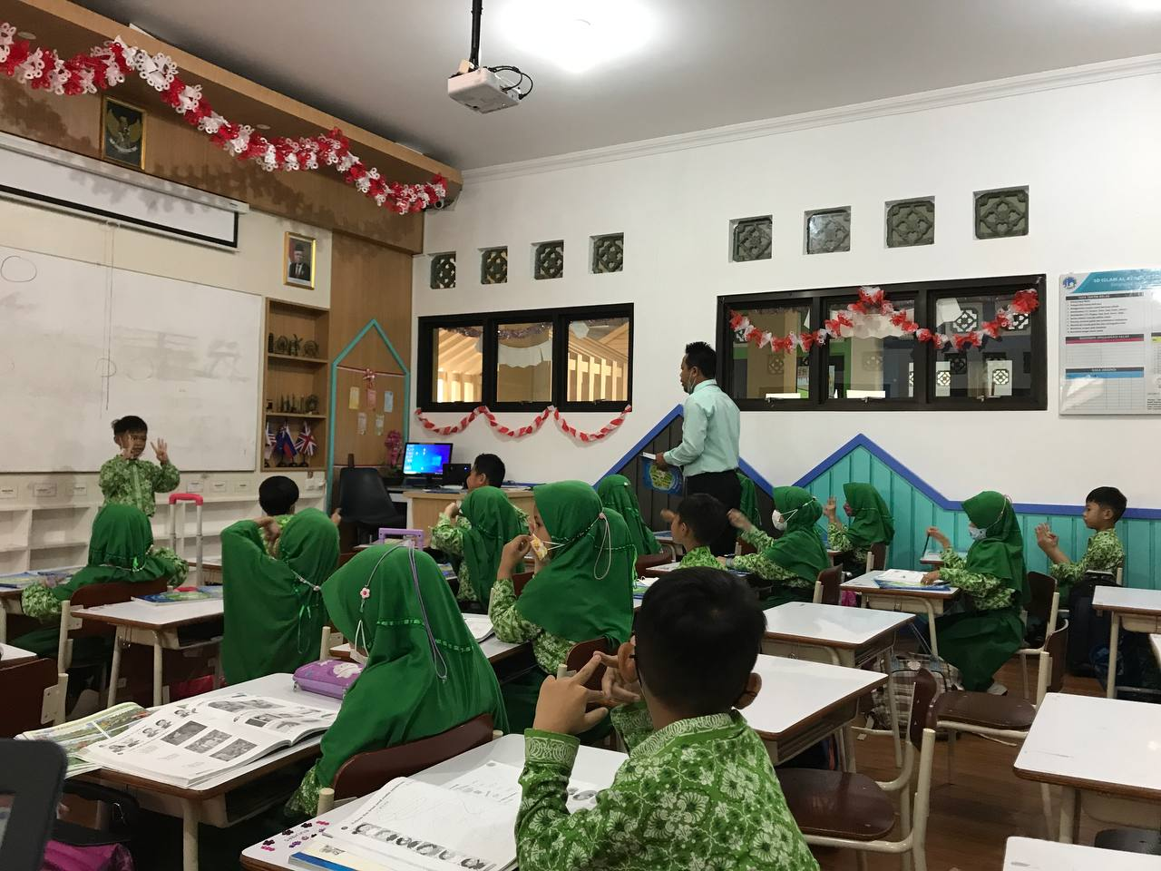
Figure 3. pre-praying using finger’ song
Mr Fa did apperception before teaching the materials by giving the review of previous materials and related to the new materials of that day. It was discussed about “Lunch Menu”. He spilled the materials about grammar “I have/haven’t got” and related to the real activities of the students. The following statements based on the observation data.
“Mr Fa: We are ready to discuss unit 4. And learn new vocabularies, we have banana, sandwich, cake, pizza, chicken, steak, peas, carrot. We also discuss about I’ve got and I haven’t got banana, sandwich, apple, it has been already discussed in our previous meeting, right? How to mention the menu in your lunch box using English?
Students: Yes. I have.”
(Observation in Mr Fa’s class, Wednesday, 13rd November 2022)
In this part, Mr Fa explained the use of I have got and I haven not got in grammar. It usually used to mention the menu of the foods. The materials only discussed the used of that grammar only for subject “I” for the grade 1. They were asked to understand how to use it and practice it by themselves first. Teacher delivered this by using E-book of Super Minds which displayed by the projector. So that young learners can focus and understand with the explanation.
- Main Activity
Based on the teacher’s document of lesson plan and correlated to the direct observation. The teacher used Activity-based Learning. Activity-based learning was an approach to teaching that involves students actively participating in the learning process through hands-on activities and collaborative problem-solving. A disruptive breakthrough in education that has the potential to revolutionize both teaching and learning is activity-based learning. Activity-based learning gives students a chance to experience and engage with concepts and information rather than simply delivering it to them as is done in a lecture.
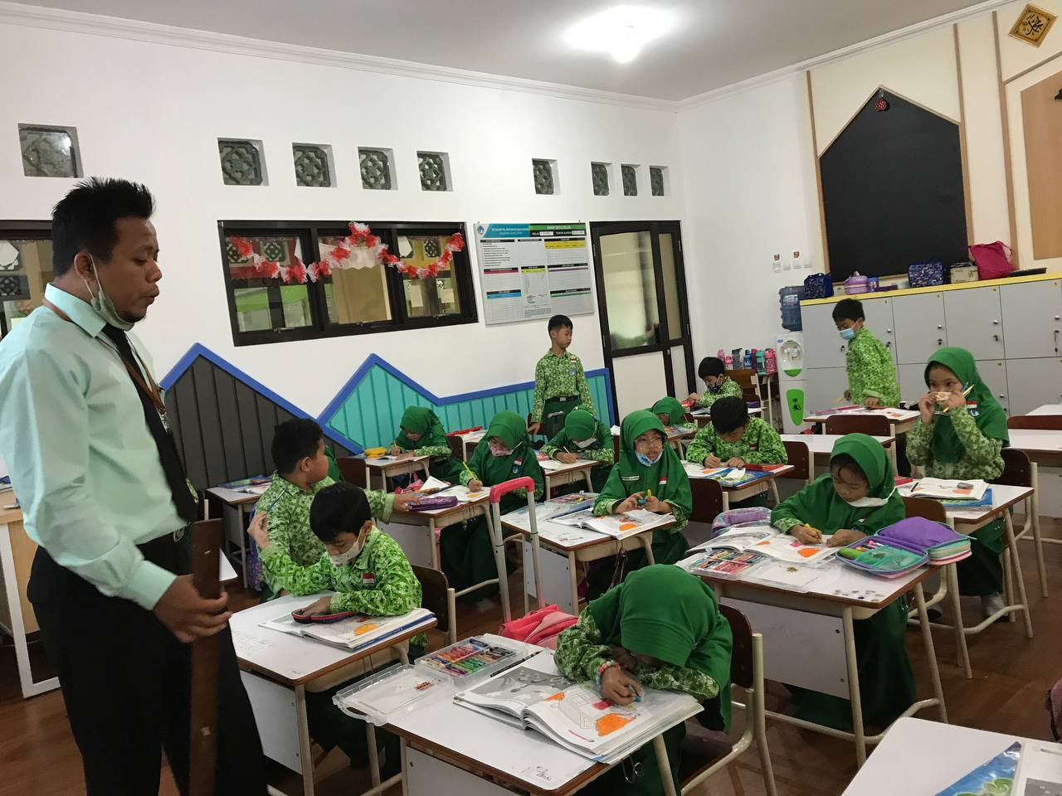
Figure 4. students’ activitiy coloring project
The process of activity-based learning was divided into three main parts: input, processing, and output.
In the input stage, teacher introduced the topic or concept to be learned through a variety of methods, such as lectures, videos, readings, or discussions. The purpose of the input stage was to provide students with a foundation of knowledge on the topic.
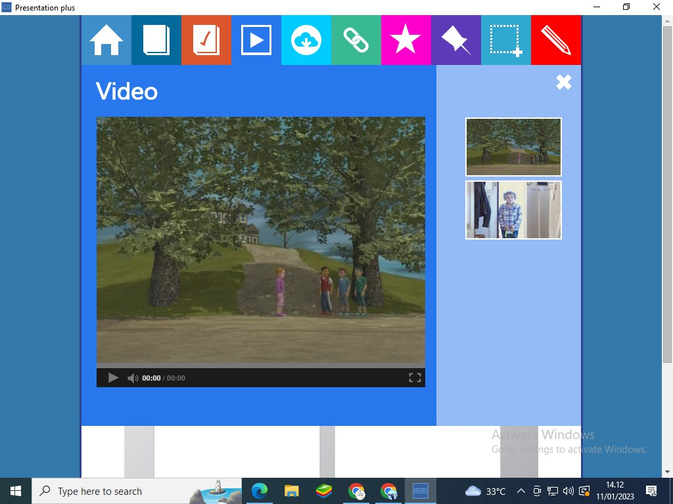
Figure 5. watching video in the beginning of learning
In input stage, Mr Fa invited the students to sing together then discussed the random lyrics of song. Teacher gave the chance to them to order the random lyrics. It was proved by transcript taken from first observation. Teacher tried inviting the students to communicate in discussion.
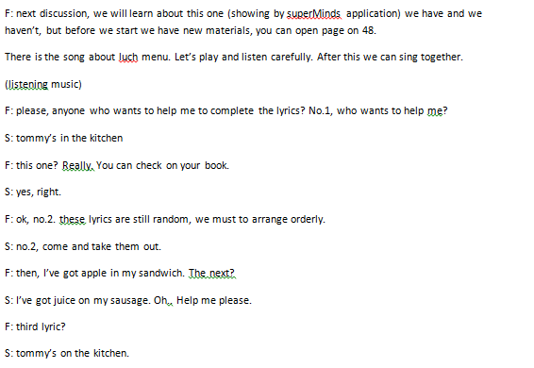
Figure 6. transcript of main activity taken from first observation
In the processing stage, students engaged with the material and applied what they had learned through a variety of activities and exercises. It included group of projects, individual assignments, role-playing scenarios, or simulations. The purpose of the processing stage was to encourage students to think critically, ask questions, and apply their knowledge in practical ways. In the output stage, students reflected on what they had learned and demonstrated their understanding through a variety of means, such as presentations, written reports, or creative projects. The purpose of the output stage was to allow students to consolidate their learning and demonstrate their understanding in a meaningful way.
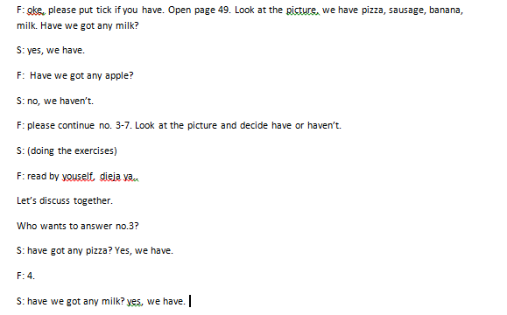
Figure 7 class interaction between teacher and students
The processing stage can be found when teacher asked the students to put the sticker on the appropriate statements. This activity was interesting, because the learning process not only by reading, writing, or listening but the students can use the facility of Super Minds book that giving some sticker in the last page of the book, students used and applied correctly with listening the instructions of the teacher.
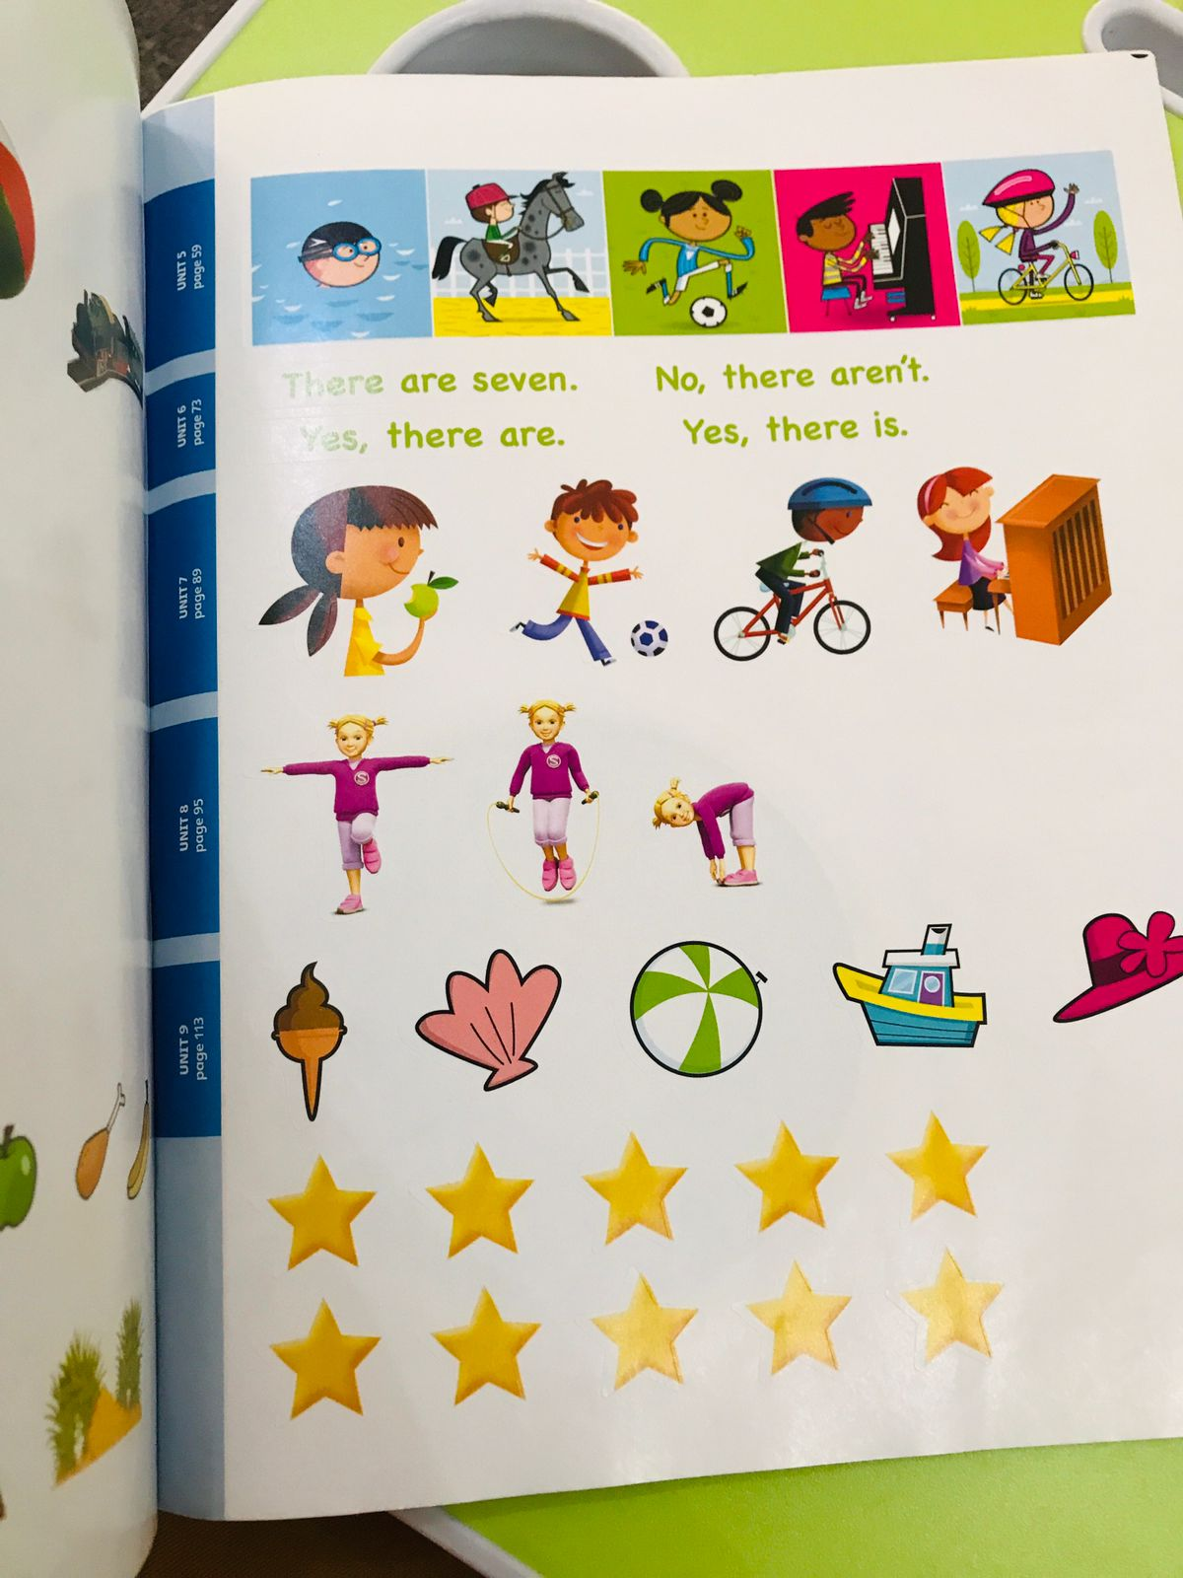

Figure 8 students’ task model using stickers
The output stage in activity-based learning was a dynamic and interactive phase where learners actively participate in hands-on activities, express students’ creativity, collaborate with peers, receive feedback, and reflect on their learning journey. It enhances the overall learning experience and helps learners become more competent and confident in their knowledge and skills.
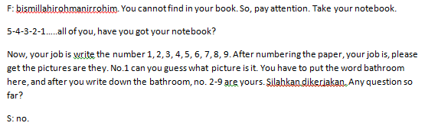
Figure 9 teacher’s instruction
Teacher instructed the students to make number 1-9 on their own papers, they must guess the pictures and write down the name of picture based on the numbers that they had make it. This section was good to know how far the students’ creativities.

- Closing
In this part, teacher ended the learning activity by giving conclusion of the materials discussed, delivering the next topic, he close by reciting hamdallah and salam. There was not homework for students.
“F: Time over, thanks for your attanetion, see you next meeting. Let’s close by recite doa kafarotul majlis.
S-f: Subhanakallahumma wabihamdika ashadu alaha illaha anta astaghfiruka wa atubuilaik.
F: Thank you, waassalamualaikum wr. wb”
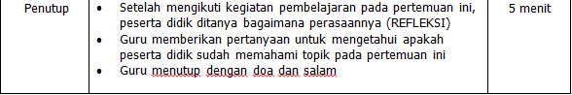
Figure….Closing Section On Lesson Plan
- Material
Learning English for young learners must be carried out in an innovative way in the delivery of material. Teacher delivered material based on the skill, each skill for each meeting. For the implementation of teaching English to young learner using Cambridge curriculum, the school has used Cambridge book during 10 years. One of the products is Super Minds English book that supported by E-book whose have many interactive features to support students in learning English especially for young learners. Students were facilitated to use the same E-book as teacher that can be activated using barcode. Each student got different barcode.
The implementation of Cambridge curriculum in teaching learning English for young learners at 1st grade of SD Islam Al Azhar 28 Solo Baru was conducted and completed with lesson plan prepared by teacher. The material of teaching learning process was “Lunch Menu” and “The Parts of House” with the objectives as the followings.
- Distinguishing some vocabularies about food and parts of house
- Capable in repeating vocabularies with the clear pronunciation.
Capable in practicing some activities based on the instruction
The material used at SD Islam Al Azhar 28 Solo Baru is categorized into printed material (student’s book and student’s activity) and e-book completed with audio and video.
- Printed material
Printed materials are physical materials, such as books, handouts, worksheets, and other documents that are produced by printing text, images, or graphics on paper or other types of surfaces. Printed materials can be an effective tool for teaching and learning in the classroom, as they can be used to present information, provide practice exercises, and reinforce concepts. It is easy to access and distribute to students. They can be distributed in class, taken home for homework, or used for independent study. The outcome is to provoke students straight forward in studying English. Based on observation result, the printed materials used in SD Islam Al Azhar 28 Solo Baru were handbook launched by Cambridge Assessment, the school used Super Minds as the main material book and the worksheet. The book was written by Herbert Puchta, gunter Gerngross, and Peter Lewis-Jones.
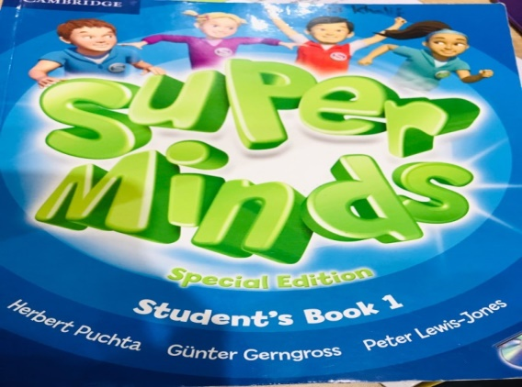
Figure 10. student’s book of Super Mind Level 1
Figure 6. Handout Book of Super Minds
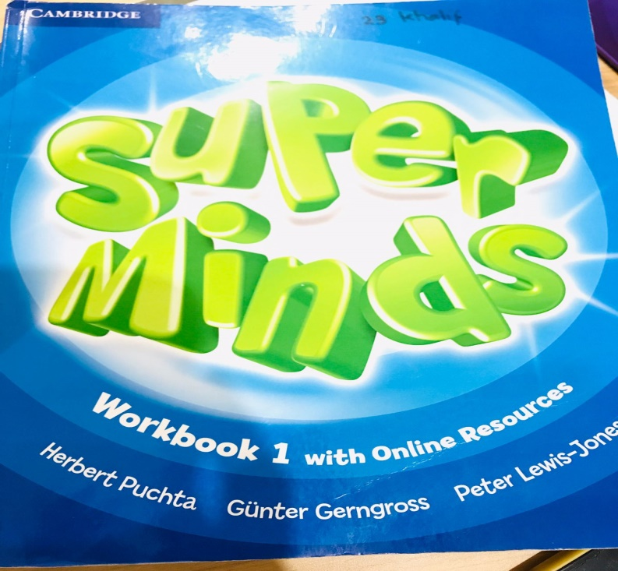
Figure 11. Workbook of Super Mind level 1
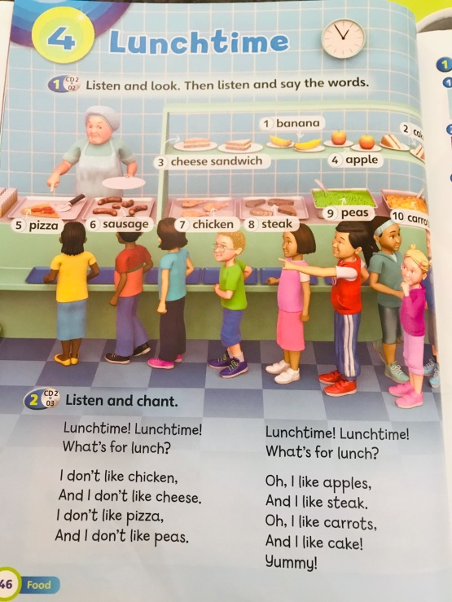
Figure 12. lunchtime material level 1
Meanwhile, a workbook is a printed educational resource that contains exercises, activities, and practice problems for students to complete. Workbooks were commonly used in classrooms as a tool for reinforcing concepts and providing practice opportunities. Super Minds contains some of worksheets and divided by each chapter.
Worksheets usually had instructions or directions at the beginning, explaining what the student was supposed to do or what the worksheet was intended to accomplish. It contained questions or problems related to the topic or skill being taught. The question’s forms were multiple choice, short answer, or open-ended questions, and may require students to solve equations, fill in blanks, or identify vocabulary words. In Super Minds contained graphics or images to help illustrate concepts or provide visual aids for students. It was useful tool for teaching and learning, providing structured practice opportunities for students to reinforce their understanding of concepts and skills. It was used as a supplement to classroom instruction or as an independent learning activity.
- Audio material
Audio material defined as resources that use sound or spoken language as the primary mode of conveying information or instruction. Audio materials used in classrooms as a tool for teaching and learning to help students develop listening and comprehension skills. Super Minds provides the audios to sustenance the listening skills of students. Spelling words, songs, short conversation, short movie were commonly delivered for young learners.
Figure 13. Audio Material

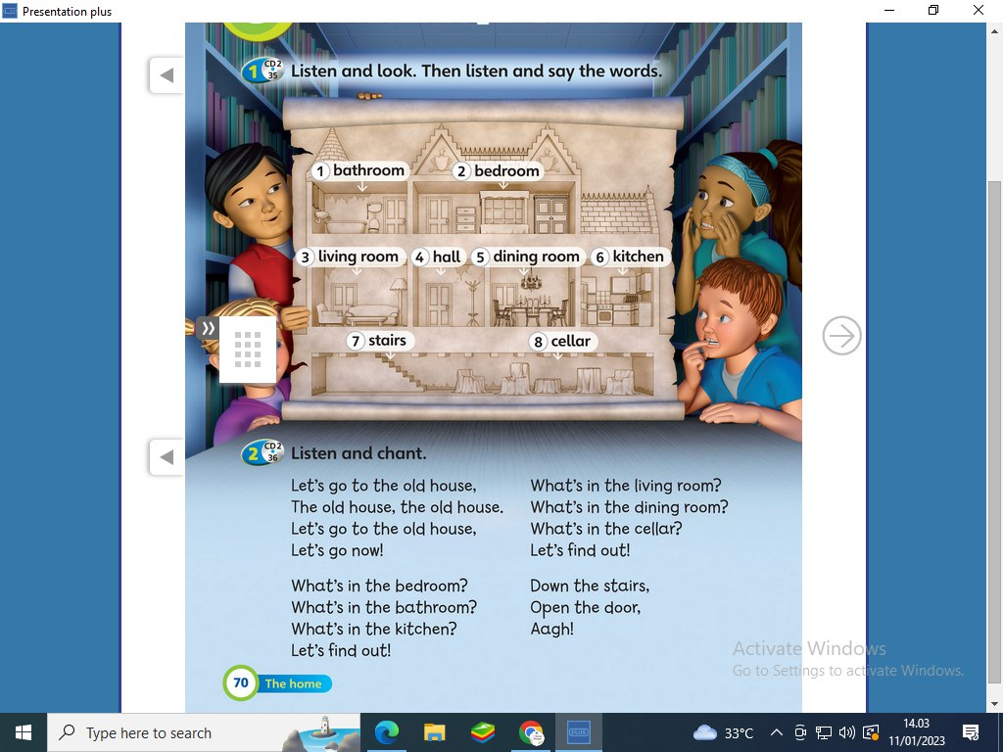
Figure 14. Material of parts house
.
- Media
Learning English in digital era cannot be denied, people need some supports from media to ease their works. It was a helpful thing that can be distributed the message from the teacher to students. Students were more active and creative. They did not need much time to learn English in the class. The media was used by teacher were video, quizizz, spin wheel and E-book of Super Minds .
Teacher sometimes used video downloaded from Youtube that related to the materials. Showing the video was additional way to entertain students. Quizizz was the application serve some educative quiz that can be customized by the creator. Teacher usually used this application and asked the students to answer the questions based on the rotation from the students numbers. Another application used spin wheel. Teacher made some questions from and presented by spin wheel. E-book was the most media used by teacher because it supported students to understand the materials easily. Teacher could use some features such as audio for listening and matching words for learning grammar and writing. But in the class, students could not operate the application directly because of the limited device. They were still focus and active when they were learning English used the E-book. For reading skill, they only used student’s book and they could practice in reading log session.
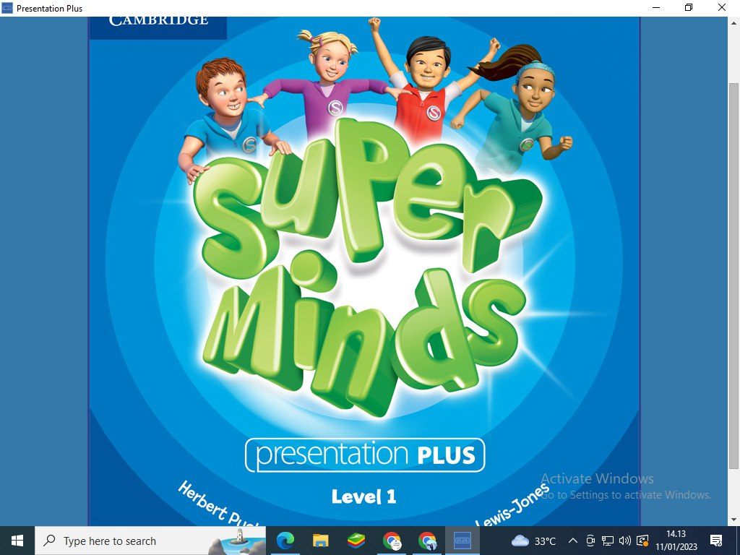
Figure 10. E-book Super Minds for 1st Grade
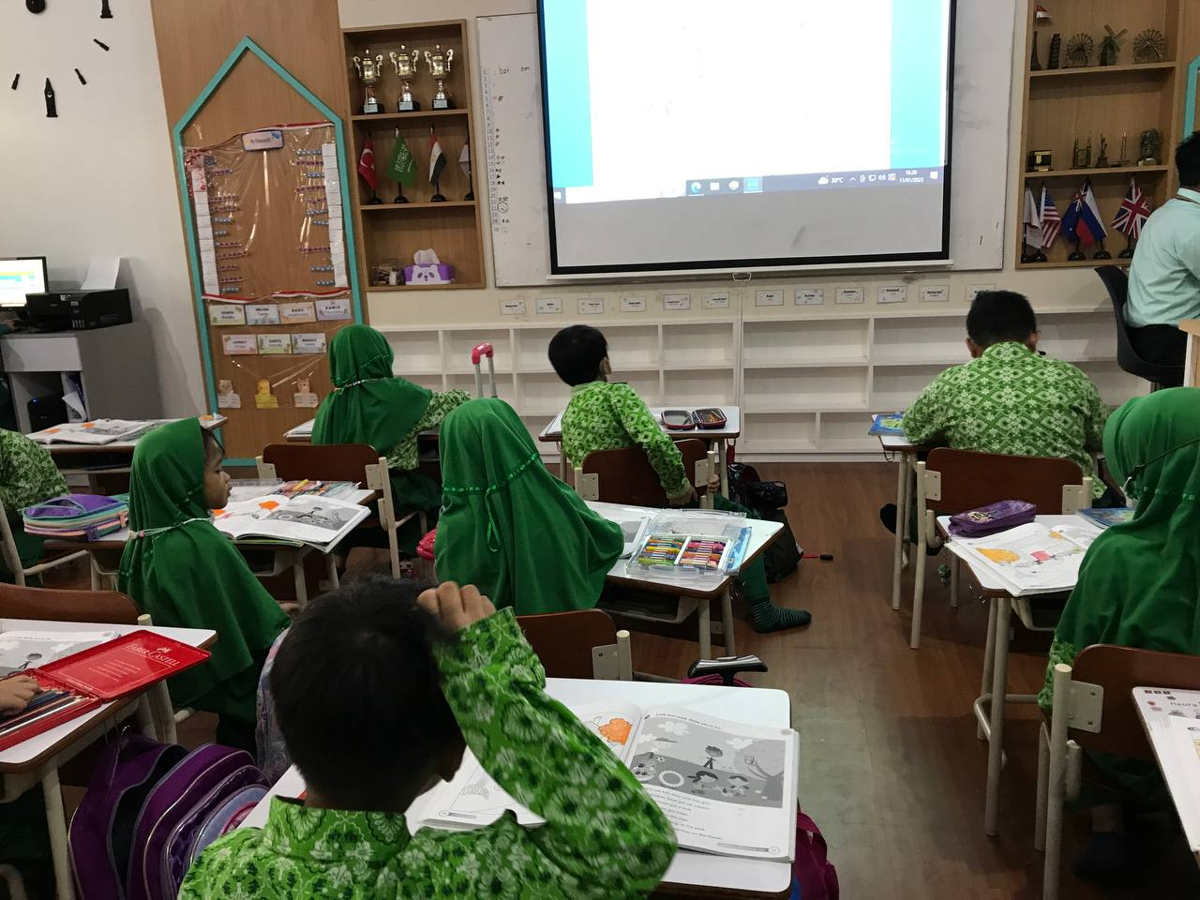
Figure 11. Using projector Screen as supporting Media of Teaching Learning English
- Assessment
Assessment was conducted to measure students’ achievement after they learn the materials using Super Minds. English assessment in this school was carried out in three kinds, Daily Test, Penilaian Tengah Semester (PTS), Penilaian Akhir Semester (PAS). Daily test was held after all materials already learned and before they move to the new chapter. Penilaian Tengah Semester (PTS) or mid-term test was conducted in the middle of semester or once in 3 months. While, Penilaian Akhir Semester (PAS) or final test was conducted in the last semester.
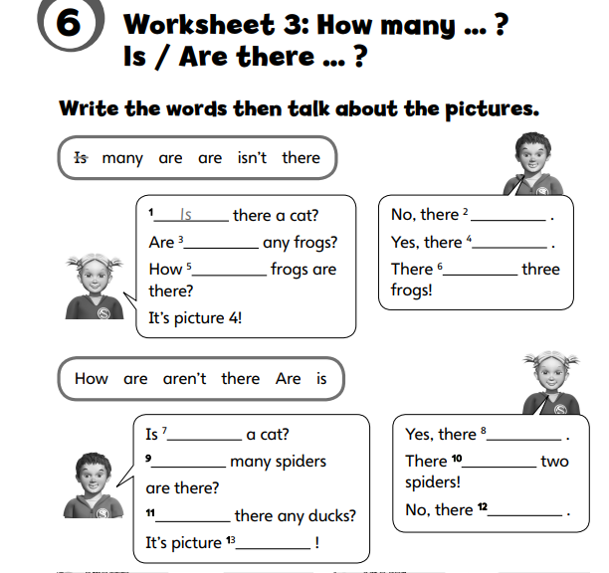
Figure 12. Worksheet adopted from Workbook of Super Minds
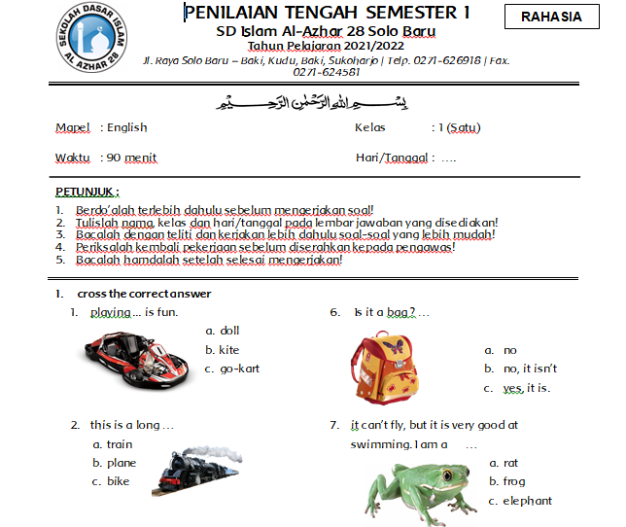
Figure 13. Daily Test created by Teacher for 1st Grade
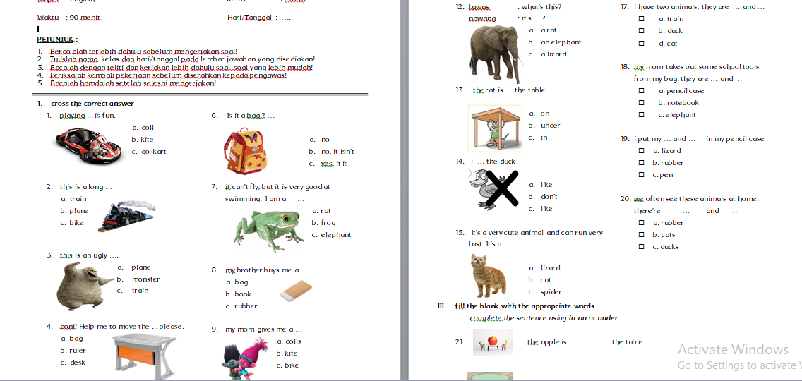
Figure 14. Middle Term Test Created by Teacher
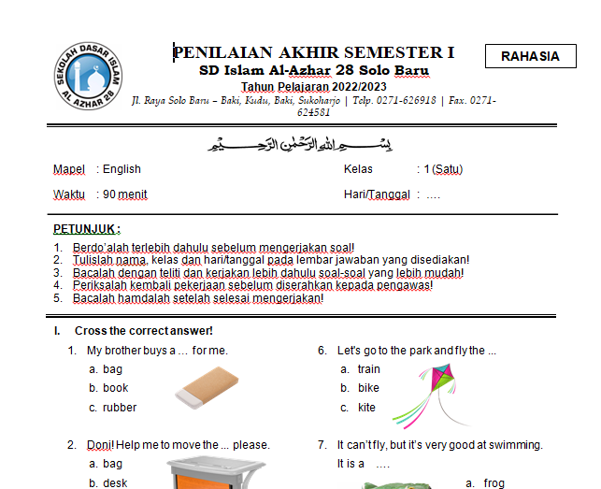
Figure 15. Final Test Created by Teacher
Teacher created the questions of middle term test and final test based on the Cambridge question’s standard for 1st grade. For daily test, the questions adopted from the worksheet of Super Minds books because the questions were simple and easy to understand.
In the research, the teacher used some assessment models that used in daily test, middle term test and final test assessments.
- Multiple choice
this model is delivering 3 choices of possible answers. The teacher created the questions used supporting pictures to help students answer the questions. The questions stood 1 simple sentence taken by some materials that students had learned.
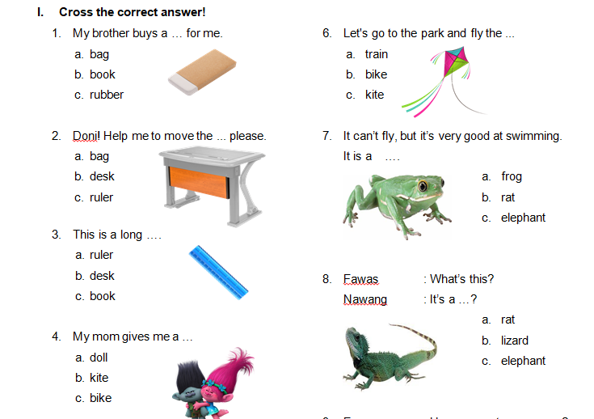
Figure 16. Multiple Choice Model
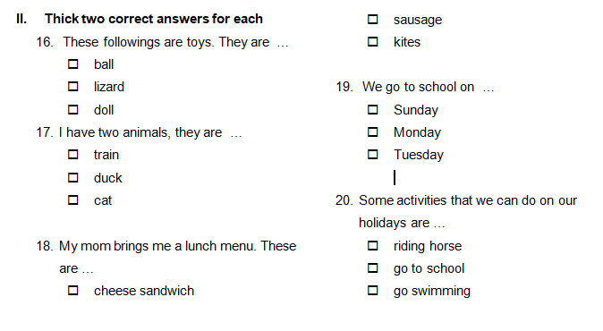
Figure 17. Complex Choice Model

- filling the blank
the students answered the question by completing the appropriate words depend on the questions. The questions’ model adopted simple sentences to make easy students answer the questions.
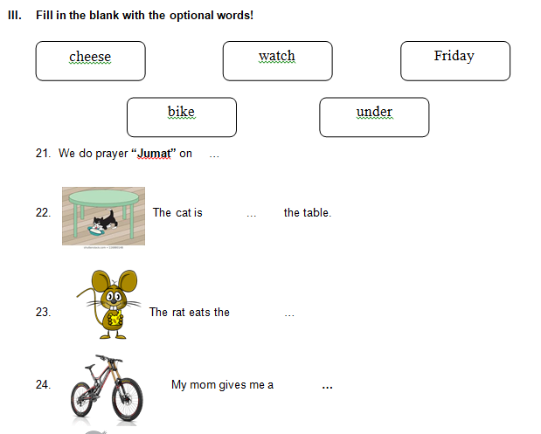
Figure 18. Filling The Blanks Model
- Listening task
The models of the test for grade 1 were various. In Cambridge listening task, it instructed the students to listen the audio and coloring the picture based on the instruction. It was simple model to habituate the students to listen the native speakers.
Every meeting, teacher played the audio containing short conversation and certain words based on the topic discussed.
Listening lunch menu
Figure 18. Listening Task
Based on the class observation, the exercise in assessment were adapted from student’s activity’s book grade 1. Meanwhile, for daily test, teacher adopted the task from the E-book of Super Minds which only could be accessed by English teacher. The level of listening test was standard for the young learners in 1st grade.

- Grade 4 teacher
Observation was held on October 10th 2023 and January 13th 2023 to collect the data from Mrs. D who teaches at 4 Umar regular programs. Regular program was one of program at SD Islam Al Azhar 28 Solo Baru which the students used Indonesian in learning activities although they studied English, they needed the Indonesian interpretation from teacher when teacher explained the materials. It was different from bilingual program where the students mostly speak English in daily activities.
- Method
Based on observation, the teacher used audio-visual and translation method in teaching English at 4th Umar grade of SD Islam Al Azhar 28 Solo Baru. Incorporating audio-visual aided in teaching English to 4th-grade students was an effective way to engage them in the learning process and enhance their language skills. It was frequently used by presenting short educational videos that cover topics related to the English language, such as grammar rules, vocabulary, and pronunciation. In addition, teacher used audio recordings of native English speakers reading stories, reciting poems, or engaging in conversations. Students could listen to the recordings and practice their listening and speaking skills by repeating what they hear.
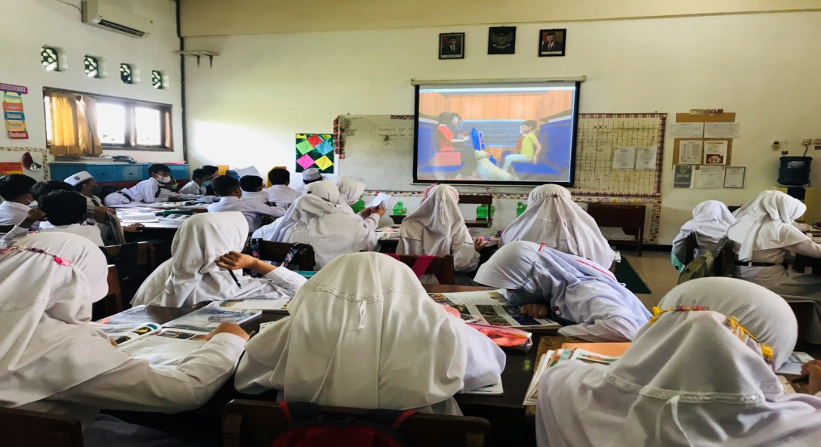
Figure. Teaching English used audio-visual by presenting video from Super Minds E-book
Cambridge curriculum provided a wide range of audio-visual material for teaching English to 4th-grade students. Their material included videos, songs, games that were specifically designed to engage and motivate young learners. The audio-visual materials provided by Cambridge curriculum were helpful for teacher in delivering English language instruction to young learners. Teachers used and delivered the materials to create dynamic and engaging lessons that help students developed their language skills in a fun and interactive way.
In the same condition, teacher used translation frequently, especially when young learners were struggling to understand a concept in English. Most of students came from native language of Bahasa Indonesia. The method was important to use it in a way that supports language learning. Every student has different capability in mastering English, furthermore they had to learn second language that being challenge for them to adapt and try to communicate correctly. Teacher offered the solution to use translation to make easy and clear students’ understanding about the materials. As the teacher said in interview section below:
“kalo untuk kelas 4 lebih condong ke audio visual karna berdsarkan aplikasi juga mereka cenderung ke audio visual, klo translation masih dipakai untuk mendampingi metode lainnya karna kalo kita tarik kebelakang, mereka memiliki kemampuan berbeda, di sekolah kita menganggap sama ada yang kesusahan ada yang terlalu muda, jadi otomatis yang standar kita udah bagus tapi kita masih mamakai metode GTM”.

- Classroom procedure
Based on the observation with Mrs. D, she taught regular class which students used English only in learning English subject. Teaching English was implemented by luring consist of 3 stages, namely opening, main activity, and closing. The class duration was 30 minutes in an hour of learning. The brief pattern of classroom procedure as follows:
- Opening
Based on the both observations, at the beginning Mrs. D opened by salam and chose two students to lead the praying. As usual, she greeted and checked students’ attendance before the class begins. There were not students who leaved the class.
Mrs. D did apperception before delivering new materials by reviewing the previous materials which discussed about The Situation At Train Station and Mythical Beast. She related the new material with the previous material. The following statement based on the observation.
Mrs. D: all right students, today we are going to learn about how to telling time which correlated with the vocabularies of situation at train station. Time is needed to know when we’re going to somewhere if we go by train. The a nnouncer will remind us the time of departure and time of arrival. That’s why we have to know how to mention time in right way”.
(observation 1 in Mrs. D class, Friday, October 10th 2022)
In this section, Mrs. D also conveyed the wisdom and benefits gained from studying about telling the time and delivered the things to be learned and competencies to be achieved. The objective of the learning presented using e-book of Super Minds for 4th grade.
The opening was conveyed based on the lesson plan instructions and the teacher stated in the interview section.
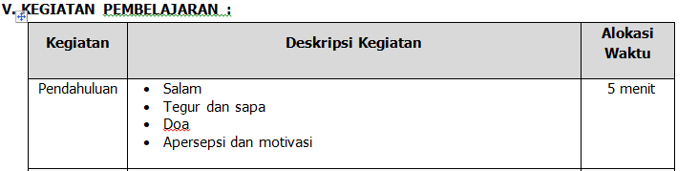
Figure…. Opening of learning activity
“D: kalo untuk membuka dan menutup harus disesuaikan dengan SOP yang ada di sekolah. Membuka dengan salam, doa belajar, greeting, closing juga seperti itu. Kalo closing di kelas saya itu kan jamnya tidak di akhir pelajaran jadi tidak membaca doa penutup, hanya membaca hamdallah saja”.
In learning activities, the steps in teaching have been determined in the lesson plan and include the parts to be assessed. Each teacher had different styles of opening lessons, but the important parts that must be included are opening lessons, namely greetings, greeting, praying, apperception, and giving motivation.
- Main activity
Based on the teacher’s document of lesson plan and correlated to the direct observation. The teacher used Activity-based Learning. Activity-based learning was an educational approach that emphasizes active engagement and hands-on experiences as the primary means of acquiring knowledge and skills. This approach is rooted in the belief that students learn best when they are actively involved in the learning process, rather than passively receiving information from a teacher or textbook. The learning process through hands-on activities and collaborative problem-solving. A disruptive breakthrough in education that has the potential to revolutionize both teaching and learning is activity-based learning. Activity-based learning gives students a chance to experience and engage with concepts and information rather than simply delivering it to them as is done in a lecture.

- Closing
In this part, Mrs D ended the learning activity by giving conclusion of the materials discussed, delivering the next topic, he close by reciting hamdallah and salam. There was not homework for students. It explained by Mrs D in interview section as below:
“Penutupnya yaitu kita review materi hari ini, untuk latihan berdasarkan skill yang dipelajari, ada kalanya kita hari ini belajar listening, speaking, writing, reading, latihan soal hanya dilakukan saat mendukung dulu. Biasanya sebelum LK kita adakan review semua materi. Setelah dilakukan review, saya akan menanyakan perasaan anak-anak setalah belajar materi tersebut dan menyampaikan rencana kegiatan yang akan dilakukan pada pertemuan yang akan datang. Ditutup dengan berdoa yang dipimpin oleh anak-anak dan salam”.
Closing the learning activities carried out by Mrs. D was in accordance with the lesson plan as follows:
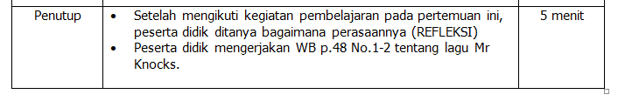
Figure…..closing activity
- Material
The material was adopted from the product of Cambridge curriculum. the school used the Super Minds as the main handout that teachers and students also used in teachings and learning activities. Different from bilingual class, the students of grade 4 only used the student’s book. Workbook of Super Minds was not distributed to the regular students since the regular students only had 3 hours of English class in a week. Teacher did not add other materials from another source because the student’s book of Super Minds has complex materials and enough to deliver to the students.
The implementation of Cambridge curriculum in teaching learning English for young learners at 4th grade of SD Islam Al Azhar 28 Solo Baru was conducted and completed with lesson plan prepared by teacher. The materials of teaching learning process was “Two Return Tickets” and “Mythical Beasts” with the objectives as the followings.
- Distinguishing some vocabularies about the things around the station and the part of the animals.
- Capable in repeating vocabularies with the clear pronunciation.
- Capable in practicing some activities based on the instruction
The material used at SD Islam Al Azhar 28 Solo Baru is categorized into printed material (student’s book) and e-book completed with audio and video.
- Printed material
Printed materials are physical materials, such as books, handouts, worksheets, and other documents that are produced by printing text, images, or graphics on paper or other types of surfaces. Printed materials can be an effective tool for teaching and learning in the classroom, as they can be used to present information, provide practice exercises, and reinforce concepts. It is easy to access and distribute to students. They can be distributed in class, taken home for homework, or used for independent study. The outcome is to provoke students straight forward in studying English. Based on observation result, the printed materials used in SD Islam Al Azhar 28 Solo Baru were handbook launched by Cambridge Assessment, the school used Super Minds as the main material book and the worksheet. The book was written by Herbert Puchta, gunter Gerngross, and Peter Lewis-Jones.
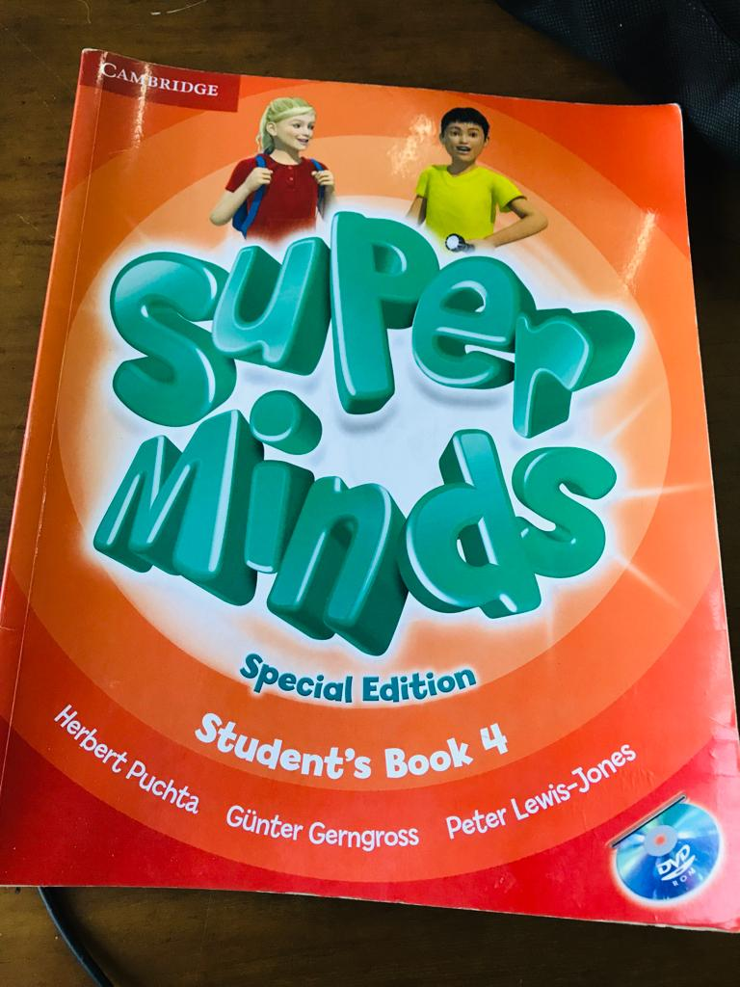
Figure…. Student’s book of Super Minds for grade 4
- Audio material
Audio material defined as resources that use sound or spoken language as the primary mode of conveying information or instruction. Audio materials used in classrooms as a tool for teaching and learning to help students develop listening and comprehension skills. Super Minds provides the audios to sustenance the listening skills of students. Spelling words, songs, short conversation, short movie were commonly delivered for young learners.
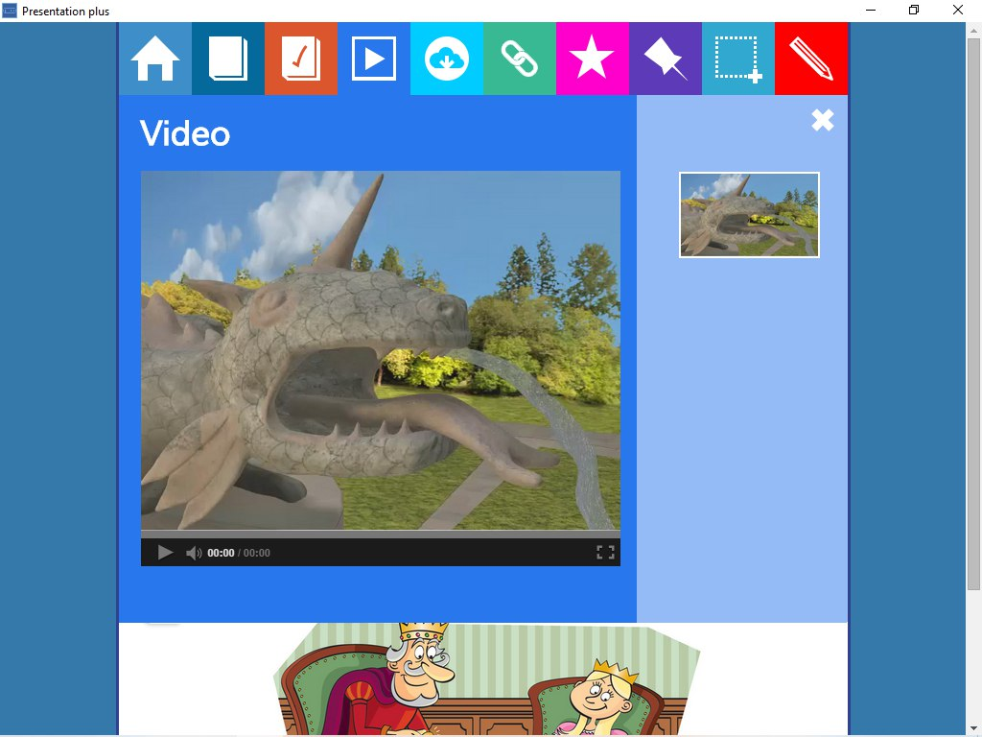
Figure ….. video Material

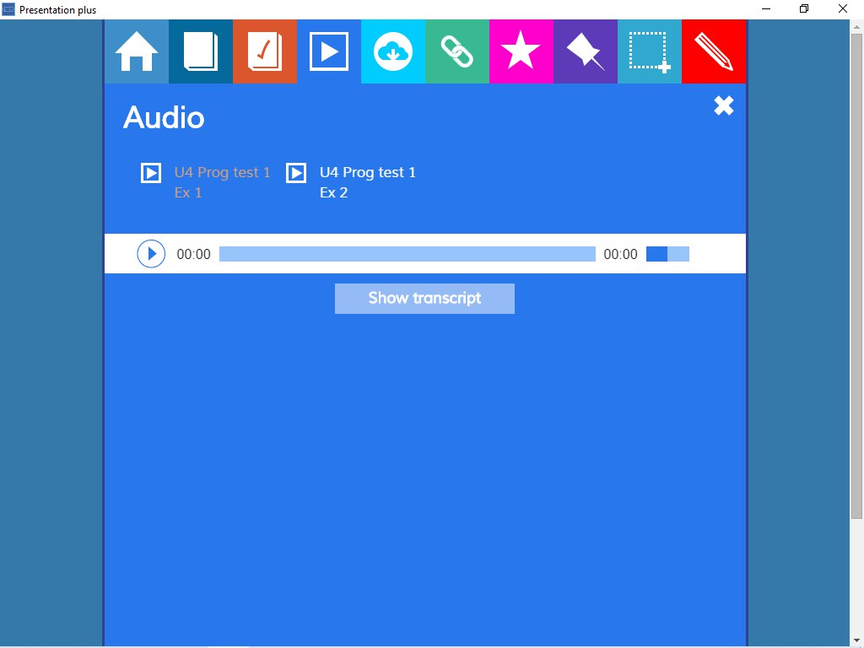
Figure ….audio material
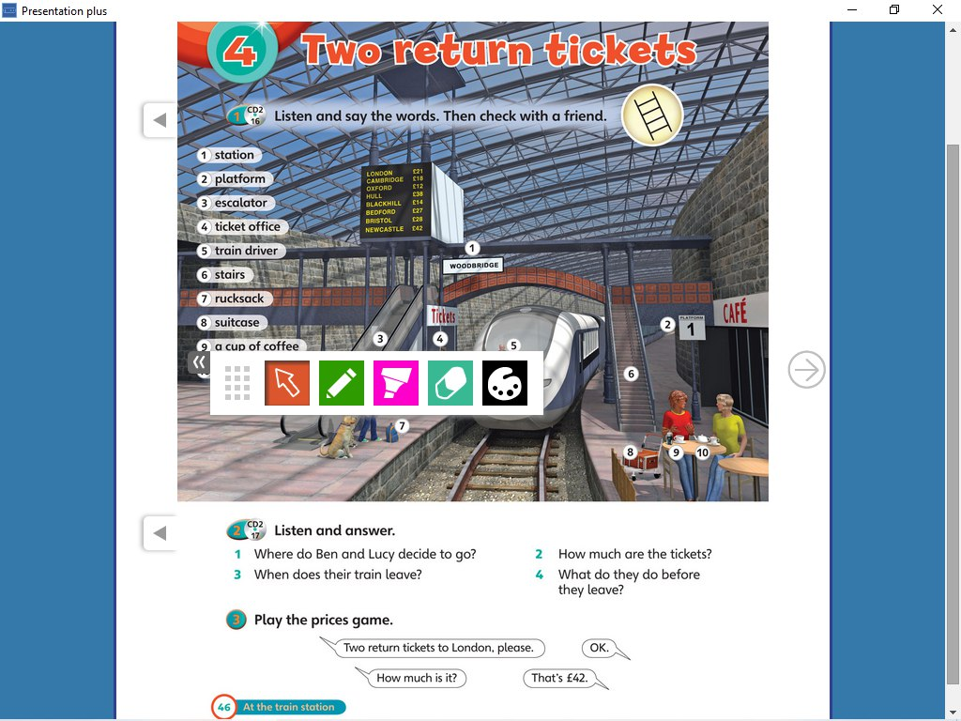
Figure 9. Material of Two Return Tickets.
- Media
Media played a crucial role in learning English as a second language. It provided learners with opportunities to immerse themselves in authentic language use, exposes them to various accents, dialects, and cultural contexts, and enhances their language skills in an engaging and interactive manner. It also offered a wide range of vocabulary in context, allowing learners to learn new words and phrases and understand their meanings and usage. Through exposure to diverse genres, learners acquired specialized vocabulary related to different fields.
For young learners, media was important thing to support them in learning activity. There were various form such as cartoons, animated movies, and interactive apps, captivate the attention of young learners. The visually appealing and interactive nature of media content kept them engaged and motivated to learn English. Media exposed young learners to English in a natural and authentic way. They could listen to spoken English, observed facial expressions, body language, and gestures, and understand the context of the language. It helped children develop their listening skills and builds a foundation for language acquisition.
In grade 4 of SD Islam Al Azhar 28 Solo Baru, e-book was the most media used by teacher because it supported students to understand the materials easily. Teacher could use some features such as audio for listening and matching words for learning grammar and writing. But in the class, students could not operate the application directly because of the limited device. They were still focus and active when they were learning English used the E-book. For reading skill, they only used student’s book and they could practice in reading log session.
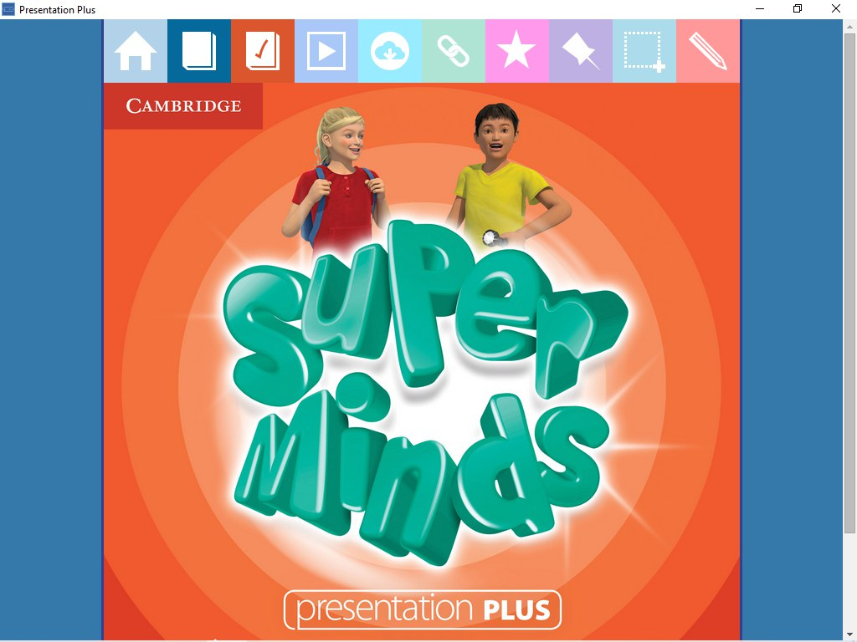
Figure….. E-book Super Minds for Grade 4
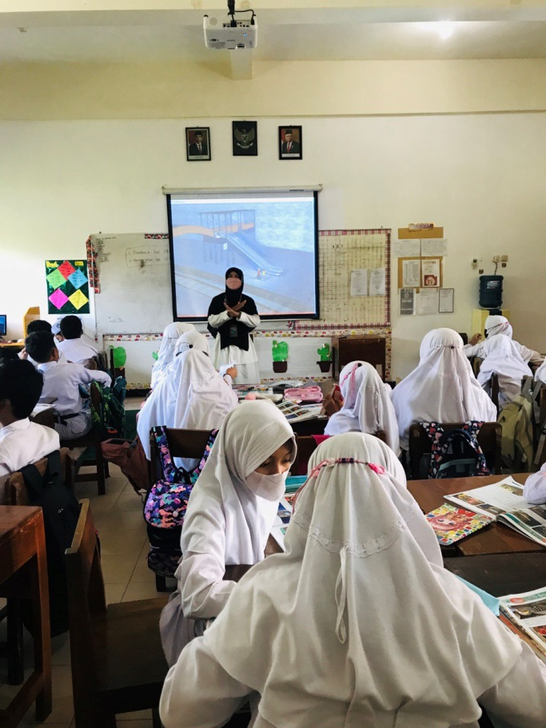
Figure ….. Projector Screen as supporting Media of Teaching Learning English
- Assessment
Assessment was conducted to measure students’ achievement after they learn the materials using Super Minds. English assessment in this school was carried out in three kinds, Daily Test, Penilaian Tengah Semester (PTS), Penilaian Akhir Semester (PAS). Daily test was held after all materials already learned and before they move to the new chapter. Penilaian Tengah Semester (PTS) or mid-term test was conducted in the middle of semester or once in 3 months. While, Penilaian Akhir Semester (PAS) or final test was conducted in the last semester.
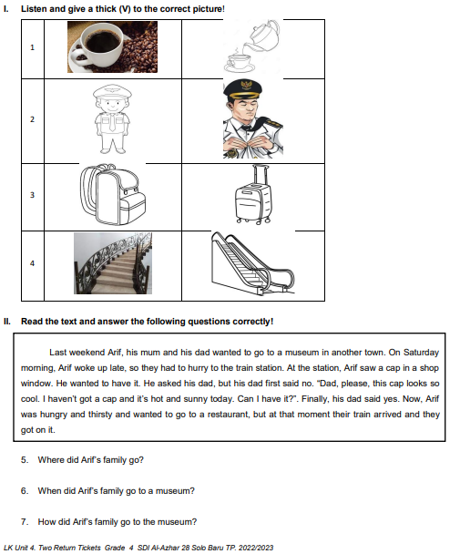
Figure….worksheet unit 4 for grade 4
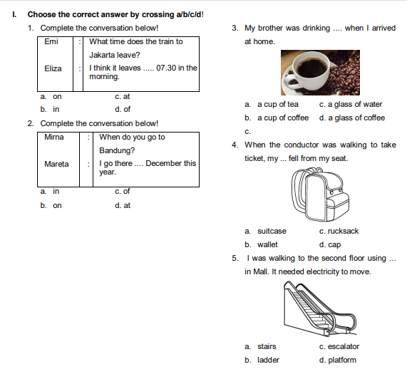
Figure…. Daily Test unit 4 for grade 4
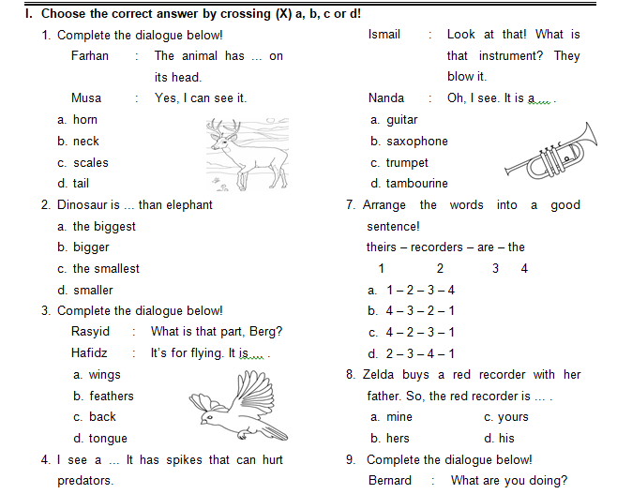
Figure... Middle Term Test for Grade 4
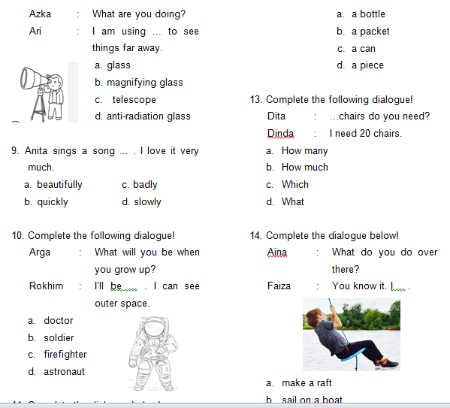
Figure ….. Final Test for Grade 4
Teacher created the questions of tests based on the Cambridge question’s standard for 4th grade. In the research, the teacher used some assessment models that used in daily test, middle term test and final test assessments.
- Multiple choice
this model is delivering 3 choices of possible answers. The teacher created the questions used supporting pictures to help students answer the questions. The questions stood 1 simple sentence taken by some materials that students had learned.
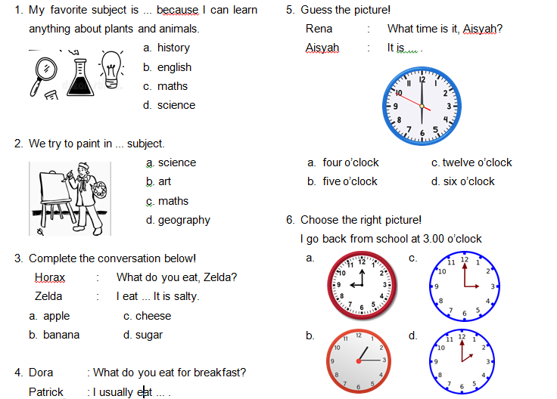
Figure 16. Multiple Choice Model
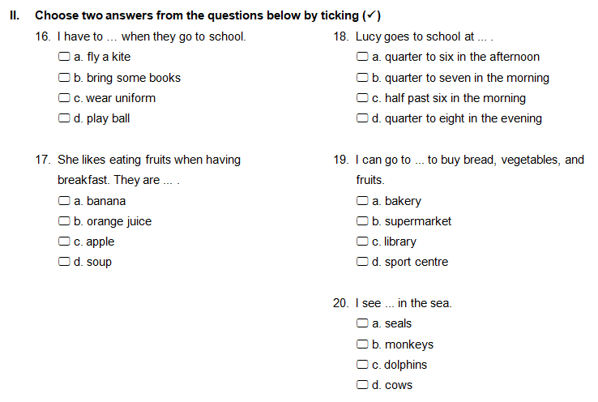
Figure 17. Complex Choice Model

- filling the blank
the students answered the question by completing the appropriate words depend on the questions. The questions’ model adopted simple sentences to make easy students answer the questions.
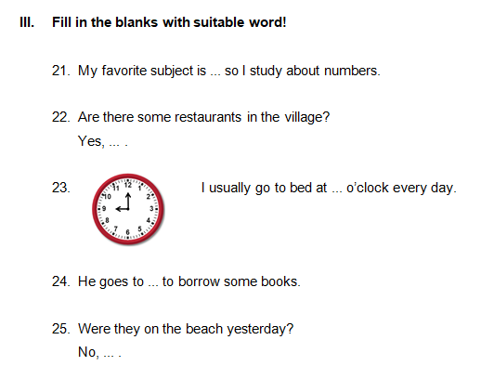
Figure 18. Filling The Blanks Model
- Listening task
The models of the test for grade 1 were various. In Cambridge listening task, it instructed the students to listen the audio and coloring the picture based on the instruction. It was simple model to habituate the students to listen the native speakers.
Every meeting, teacher played the audio containing short conversation and certain words based on the topic discussed.
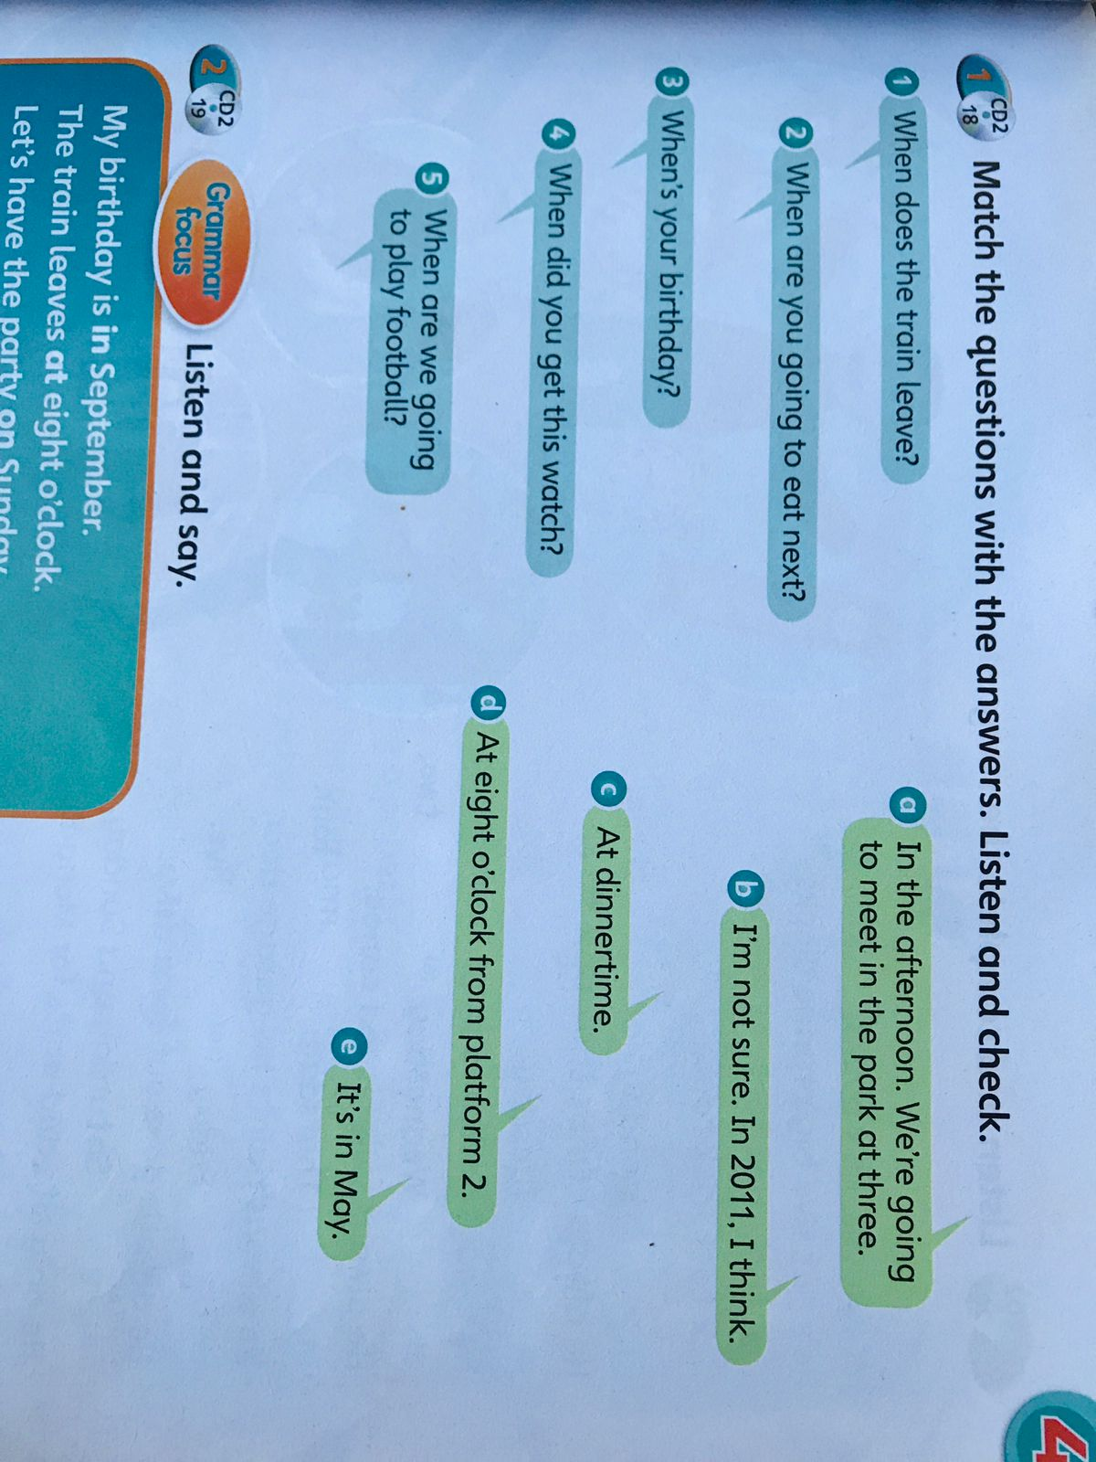
Figure 18. Listening Task
Based on the class observation, the exercise in assessment were adapted from student’s activity’s book grade 4 and it was written by the teacher. for the listening task, teacher adopted the exercises from the e-book of Super Minds.
- Problem of teaching English to young learner using Cambridge curriculum
The school was applying Cambridge curriculum in English learning. From observation and interview that had been conducted there were different problems and solution of teaching English by each English teacher of grade 1 and grade 4. The problems consist of: learner’ readiness problem, control the students to pay attention, limited reading lesson time, lack of vocabulary, and different learning styles.
  - Learners’ Readiness Problem
Based on the observation and interview results, learners’ readiness problem was found as the problem of teaching English for young learners. It refers to a situation or challenge where learners were not adequately prepared or equipped to engage with the materials or tasks being presented in an educational setting. That problem was faced by English teachers of grade 1 and grade 4. Teacher of grade 1 stated the problem on the interview as follow:
"When conditioning the classroom, the common challenge encountered in lower grades is that they tend to be kinesthetic or behave in a manner typical of children. As lower-grade teachers, we often need to prepare specific methods or techniques to handle the children”.

Furthermore, teacher of grade 4 had the same problem but in different condition. The students of grade 4 were not ready yet after they had break-time. It evidenced by her statement on the interview:
"In the 4th grade, my English class was conducted after break time, so students were sometimes not ready for the next lesson”.

The problems above were experienced by English teachers when teaching in grades 1 and 4. When the teacher was in the lower grade, students were still difficult to get ready because they were still carried away by their inner child who always want to play and move actively like toddler. In contrast to the upper class who no longer act like toddler, their unpreparedness for studying occurs due to the situation and conditions of the English schedule which takes place after break time. When the researcher conducted classroom observation, the researcher saw that grade 4 students were still eating, not yet in their seats, still chatting, go out to the toilet.
In handling this problem, the two teachers applied different strategies for each class. In the observation results, grade 1 teacher tended to imitate or position himself as someone who was friendly towards young learners by softening his voices, giving instructions that were appropriate for young learners, occasionally inviting them to sing and say basmallah. Reciting basmallah was a characteristic for conditioning students at this school. The students would follow to recite basmallah and sit down quickly and calmly as soon as possible. In the interview, grade 1 teacher stated as follow:

“As lower grade teacher, teacher usually has to prepare certain methods or techniques to handle children’s readiness. Teacher has to be more childish, positioning ourselves more at the same age as the learners. We can also use certain slogans so that they are more interested in following the lessons. The point is before opening the material, we have to prepare ourselves and make it as interesting as possible for the children”.

From the data above, the teacher explained that the alternative solution applied so that young learners got ready, he had to position himself as the same age as them, using attractive slogans so that students were ready to learn again. Different from grade 1, grade 4 teacher tended to use direct instruction to condition students when the lesson would start. This data was discovered during observation at grade 4. Grade 4's schedule was between before and after break-time. Usually the teacher gave asked to rest then continued after break-time. When teacher started learning, the teacher invited students to get ready and gave a warning that class was going to start soon. This case was proven by the statements of the 4th grade teacher during the interview.

“To prepare the student, I usually wait, but if the students are not ready yet after I have waited, I give a command, for example, "let's start our lesson". Sometimes there is a class teacher who helps condition students in learning.”

  - Limited Reading Lesson Time
The limited reading lesson time was being a challenge for teachers’ grade 1 and 4 when they handled young learners in their English classes. Students almost did not have the chances to read the books. They were focus only on the explanation of materials using Cambridge curriculum. Grade 1 teacher said:

"The diverse backgrounds of young learners in bilingual class cause of children's conditions and abilities in English are different, especially in reading skills. This must be addressed by teachers or coordinators in their fields to work around the gap or inequality between children who already have English language skills and those who do not, so that there is not too much distance, including by providing more hours of English, especially in reading."

From those statements in the interview, young learners of bilingual classes had different backgrounds, some had graduated from kindergarten and had applied English in their daily lives (TK Bilingual/International) but there were those from kindergarten who have not used two languages, so they did not have the strong basic English and only know a few vocabularies. This phenomenon caused of the confusion among young learners. Those who often used English were confident and fluent in using English. Meanwhile, for those who were still laymen, they tended not to dare to speak up, lack confidence, and were still confused about reading words.
"In elementary school, the time for English is around 1 hour = 35 minutes, so the special reading lesson time is a bit lacking." Said teacher grade 4

From the interview data above, grade 4 of the regular program had very limited time. English hours only have 3 hours a week, approximately 100 minutes a week. That means that it was very limited and it was not possible to use that hour for reading. The results of classroom observations show that the majority learn English by delivering materials, discussion, doing the exercises.
Teachers found alternative ways to fix the problem of limited reading time. The solution offered by grade 1 teacher was to create and activate an intra-school reading log program. The program was already running and a schedule has been set for once a week, Friday. This program involved classroom teachers and English teachers who teach in bilingual classes. This data was reinforced by the grade 1 teacher's statement as follows:
“To overcome, teacher created a reading log program that was included in the intra-curriculum. The schedule was scheduled once a week to provide as much English exposure as possible to create an atmosphere in English by increasing literacy in English. Reading logs were also a solution to children's interactions in reading books, because even at home they are constrained by books or time so they were not able to read books in English.”

During the observation, the solution implemented by the 4th grade teacher was to spend a few minutes listening to the students' reading. They read one page in turn. The teacher corrected their reading as they read. The media used the Super Minds book for grade 4. This was reinforced by the results of interviews with grade 4 teachers as follows:

“On the other hand, I inserted reading at certain times to read. Sometimes I accompanied them to read. Student A read from sheet 1 to the next sheet, other students adjusted their turns. If there was an inaccurate pronunciation, then I could correct it directly. When reading, I could also insert new vocabulary for them.”

That statement outlined a teaching approach where reading was integrated into the curriculum at specific times. The teacher actively participated in the reading process, provided corrective feedback when necessary, and took the opportunity to introduce new vocabularies to the students. That approach not only promoted reading skills but also enhanced vocabulary development and language proficiency. It was a hands-on and interactive method for improving language skills in a classroom setting.
  - Lack of Vocabulary
Lack of vocabulary often happened in EFL students, included in grades 1 and 4 of elementary school. From the results of interviews conducted by the researcher with grade 1 teacher, he revealed:

“In terms of ability in English vocabulary, teachers must deal with it well. This happened because the students' backgrounds were different. There were those from bilingual kindergartens so they had enough vocabulary, or from regular kindergartens who don't have any English skills at all.”

The statement was discussing about the challenge that teachers face in classrooms with students of varying English vocabulary abilities due to their diverse backgrounds. Some students came with a strong foundation in English vocabulary because they attended bilingual kindergartens, while others had no English skills at all because they did not learn English in their early education. Teacher was expected to manage this diversity effectively and help all students improved their English vocabulary skills. This involved differentiating instruction to meet the needs of groups, using various teaching methods, and providing additional support for students who are starting with limited English vocabulary.

“For grade 4 standards it was still lacking even though it was only basic vocabulary. Only a few students knew. Instruction such as "open the door, please!" Sometimes it was still difficult for them because they were not used to using it.”

The statement conveyed that grade 4 students had difficulties with basic English vocabulary, even though the vocabulary taught was quite fundamental. This deficiency in vocabulary knowledge was observed in most of the students. The example phrase provided highlights that the vocabulary instruction was about basic, everyday communication, yet the students found it challenging because they were not accustomed to using these phrases in their conversations. This situation indicated a need for more effective teaching methods, practice, or reinforcement of basic vocabulary to help the students become more proficient in using such language.

“To address, the teachers used the code switching method, combining English with Indonesian. For certain points that we found difficult, we use Indonesian more.”

The grade 1 teacher solve the problem by implementing teaching approach where code switching, or the alternation between English and Indonesian. It used to address challenges in the classroom. The choice of language (English or Indonesian) depended on the difficulty of the subject matter, with more reliance on Indonesian for difficult topics to aid students' understanding. That approach aims to strike a balance between facilitating comprehension and fostering English language learning, especially when dealing with challenging content.
“Because of the lack of vocabulary, I also had to introduce words that they did not know yet, and that would hinder their understanding of the material being taught. When there were questions or exercises, I usually gave the meaning of important words that have been translated, they could add scribbles or small notes in their books. By watching the video too, they would understand some new vocabulary.”

Different from grade 1, grade 4 teacher had solution that described a teacher's approach to addressing students' limited vocabulary. The teacher introduced unfamiliar words, provided explanations during exercises, encouraged note-taking, and utilized visual aids like videos to improve students' understanding and retention of new vocabulary. This approach aimed to bridge the vocabulary gap and facilitate better comprehension of the subject matter being taught.

  - Different Learning Style
Young learners of grade 1 had different style of learning English in the class. It was not common to observe a wide range of learning styles among young students. Some children can be kinesthetic learners that thrive through physical activities and interactive experiences. The students benefit from hands-on activities and games that engage their bodies and senses. Others were more inclined towards visual and auditory learning. Visual learners tend to respond well to pictures, charts, and colorful materials, while auditory learners excel when information is presented through listening, speaking, and group discussions. The grade 1 teacher said:

“When it came to studying in class, they had different styles. There were kinesthetic, audio-visual, auditory and so on.”

The statement highlights that students has different learning styles within the classroom. These styles included kinesthetic, audio-visual, auditory, and more. Recognizing and accommodating these diverse learning styles was essential for effective teaching and ensuring that students could engage with and understand the material in a way that suits their individual preferences and strengths. Meanwhile, grade 4 teacher had same problem. She stated:

“Because we taught in class, so there were differences in learning style. There were auditory, kinesthetic, there were also audio visual, so I used several styles in learning so that students understand what was being studied thoroughly.”

The statement highlighted the existence of diverse learning styles in a classroom setting due to the varied preferences and abilities of the students. It mentioned three main learning styles: auditory, kinesthetic, and audio-visual. To address these differences, the teacher employed a variety of teaching styles to ensure that all students could fully grasp the subject matter.

“Teachers would usually use various approaches in learning. Of course, this was also supported by the curriculum we used, namely the Cambridge curriculum. We had a club that taught teachers several teaching styles that could be applied in the classroom”

The statement showed that the teacher used alternative solutions like the dynamic nature of teaching, emphasizing the importance of using diverse teaching approaches to accommodate the varying needs of students. The Cambridge curriculum served as a guiding framework. Additionally, the existence of a teacher professional development club demonstrated a commitment to ongoing growth and improvement, equipping educators with a broader range of teaching styles to create a more engaging and effective learning environment for students. Teacher of grade 4 used alternative solution as she stated in the interview:
“I use games that involve movement, which is suitable for students who tend to be kinesthetic. Or auditory, I usually play videos, sing, or repeat actions. So it has to be balanced, so that it is balanced and can be understood as a whole.”

The statement underscored the importance of tailoring teaching methods to accommodate various learning styles. The teacher used physical movement-based games for kinesthetic learners and auditory methods like videos and songs for auditory learners. Striking a balance between these approaches ensured that all students had opportunities to learn in ways that suited their preferences, leading to a more comprehensive understanding of the material for the entire class. This approach aligned with research in education that advocates for differentiated instruction to cater to diverse learning styles.

- Discussion
This part discusses the data having been gathered displayed and analyzed in prior. There are three major scopes of results addressed. They entailed the implementation of teaching English to young learners using Cambridge curriculum, the problems, and the solution of teaching English to young learners using Cambridge curriculum.
The first research question stated, “How are the implementations of Cambridge curriculum in teaching English to young learners?” the findings show that the implementations of Cambridge curriculum used audio visual and translation, activity based learning. The finding is in line with Afriana (2017) which explores that the method of teaching using Grammar Translation Method (GTM), Direct Method, and Audio-Lingual Method.

What are the problems of teaching English to young learner using Cambridge curriculum?
3. What are the solutions of teaching English to young learner using Cambridge curriculum?

