STATEMENT OF ORIGINALITY

To:
Editor-in-chief
VELES JOURNAL

With this letter we declare that:
Title of article: A Retrospective Narrative Study of Pre-Service Teachers' Language Barrier Experiences in International Teaching Practicum
Author : 1. Iswatun Chasanah
2. Sumardi

has been approved by the co-author/s to be published in REGISTER JOURNAL, does not contain plagiarism as a whole or in parts, and is not currently being submitted/ processed in other journals.

Surakarta, March, 20, 2022
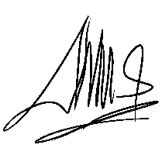
Authors Signatures

1st Iswatun Chasanah, S.Pd.

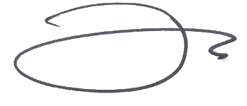

2nd Dr. Sumardi, M.Hum.

